Software Quality Engineering
Lecture 1
Introduction
Course Overview
This course helps students understand the basic concepts of software testing and how to manage testing so that software meets its requirements. It also introduces the best practices of Software Quality Assurance (SQA).
Since software is widely used in daily life and work, it is important to ensure that systems are reliable, high-quality, and work properly. In this course, students learn how to test software, find errors, and ensure it meets users’ expectations.
Reasons for Quality
- Many modern software systems are very large and complex, with millions of lines of code. Examples include Microsoft Windows and UNIX.
- These large systems are usually developed by hundreds or even thousands of developers and may take months or years to complete. They are also used in many different environments and situations, some of which may not have been expected during development.
- Because of this complexity and wide usage, it is very important to ensure high software quality and reliability.
Quality Definitions
- The American Heritage dictionary defines quality as “a characteristic or attribute of something”.
- Another definition was given by Gerald Weinberg in Quality Software Management. He said that quality means value to a person.
- This means that quality can be different for different people, because each person may judge the same software in a different way depending on their needs and experience.
Software Quality by IEEE
- Software quality means how well a system, component, or process meets the given requirements.
- It also means how well the system satisfies the needs and expectations of customers or users.
Software Quality by Roger Pressman
Software quality means that the software meets clearly stated functional and performance requirements, follows documented development standards, and also possesses the basic reliability, usability, and efficiency expected from professionally built software.
Software Quality
- Software quality depends on meeting the requirements because requirements are the basis of quality. If software does not follow the requirements, it is not of good quality.
- If software does not follow the requirements, it is not good quality. Development standards guide how software should be built.
- If a software conforms to its explicit requirements but fails to meet implicit requirements, software quality is questionable.

Quality Engineering
Quality engineering is the set of operational, managerial, and engineering activities that a company uses to ensure that the quality characteristics of a product are at the nominal or required levels.
Some key Terms
1. User
- A single person who uses a system or software.
- Example: John logs into an online store to buy products.
- So, a user = one individual.
2. User Class
- A group or category of users who share similar characteristics or needs.
- Example: “Registered users,” “Guest users,” and “Admin users” are different user classes.
- So, a user class = a type or category of users.
User Expectations-1
- Users expect the software to do the right things — it should perform the functions it is meant to do.
- Example: An airline reservation system should handle booking tickets, not fly airplanes automatically.
- The main goal is to check and make sure the software works correctly in the environment where it will be used (validation).
User Expectations-2
- The software should do its intended work without problems.
- In the airline reservation system example, the system should help travel agents or passengers make correct reservations within the given time limit, and it should not create invalid reservations.
- Focuses on whether the software performs those functions correctly without problems (verification).
Producer Expectations
People involved in developing, managing, maintaining, marketing, and servicing software products are called producers.
- For software producers, the main quality goal is to meet their agreements by making software that follows product specifications or service agreements.
- For product and service managers, quality means following selected software processes and standards and using proper methods, languages, and tools.
Quality Dimensions
Specification Quality
How clearly the requirements of the product or service are defined.
Design Quality
How well the product or service is designed before building it.
Development Quality
Following coding standards and defect prevention rules (code should be modular so it easy to debug) while developing software.
Conformance Quality
How well an organization ensures quality by applying the above three dimensions.
Understanding the problem
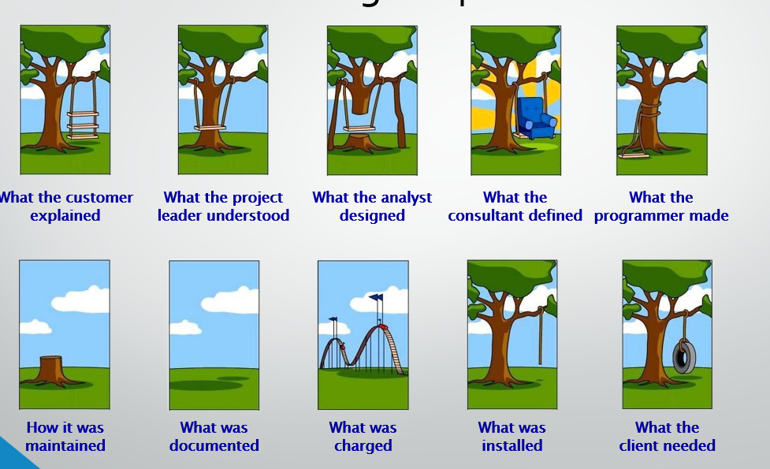
Lecture 2
Quality Frameworks
Quality Frameworks
- Quality can be defined in different ways depending on people’s views, needs, and expectations.
- Many models or frameworks have been developed to handle these different views. They help explain quality by describing its attributes, features, characteristics, and ways to measure it.
ISO/IEC 9126
International Organization for Standardization (ISO) / International Electrotechnical Commission (IEC) 9126 Standard
It provides a structured (hierarchical) framework to define software quality. In this framework, quality is divided into main characteristics and sub-characteristics.
Software Quality Characteristics
- These are a set of attributes or features of a software product that are used to describe and evaluate its quality.
- Each software quality characteristic can be further divided into smaller parts called sub-characteristics for more detailed evaluation.
ISO/IEC 9126 Overview
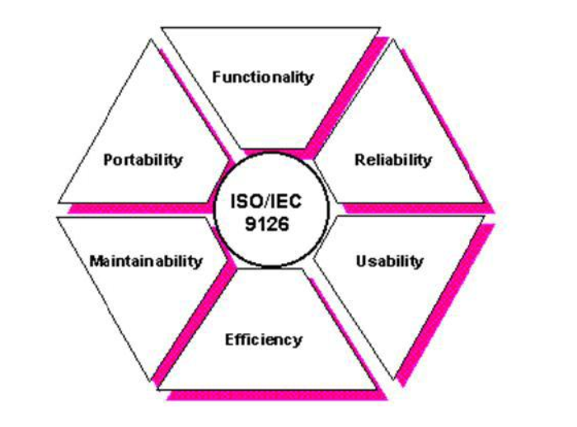

Six Quality Characteristics (ISO-9126)
Functionality:
Functionality is the main purpose of a product or service. It refers to the set of features or functions that the software provides to meet the stated or implied needs of users.
Reliability:
Reliability refers to the ability of the software to keep working correctly and maintain its performance under certain conditions for a specific period of time.
Usability:
Usability refers to how easy the software is to use and how users feel about using it. It focuses on the effort required by users to learn and operate the system.
Efficiency:
Efficiency refers to how well the software performs compared to the amount of resources it uses, such as memory, time, and processing power.
Maintainability:
Maintainability refers to how easy it is to modify, update, or fix the software when changes or improvements are needed.
Portability:
Portability refers to the ability of the software to be moved and used in different environments, such as different hardware or operating systems.

Sub-Characteristics
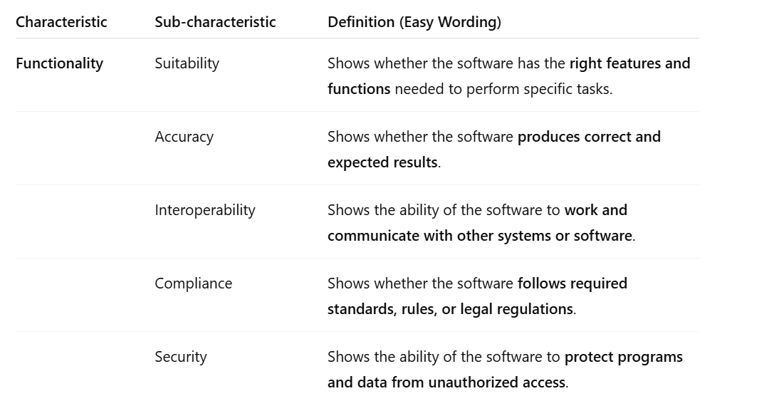
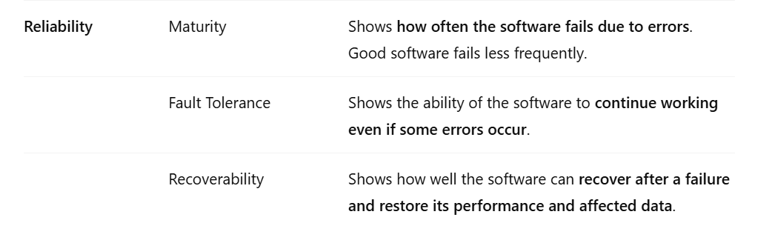
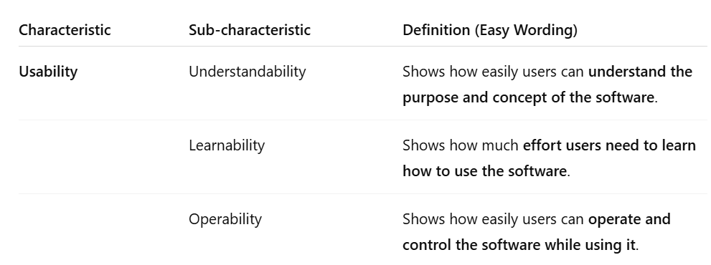

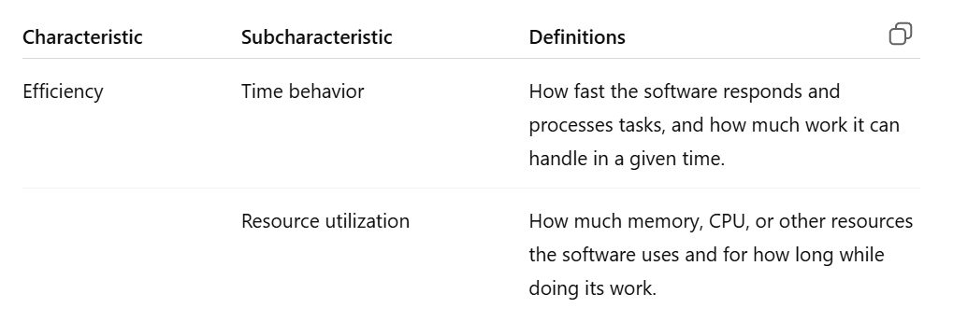
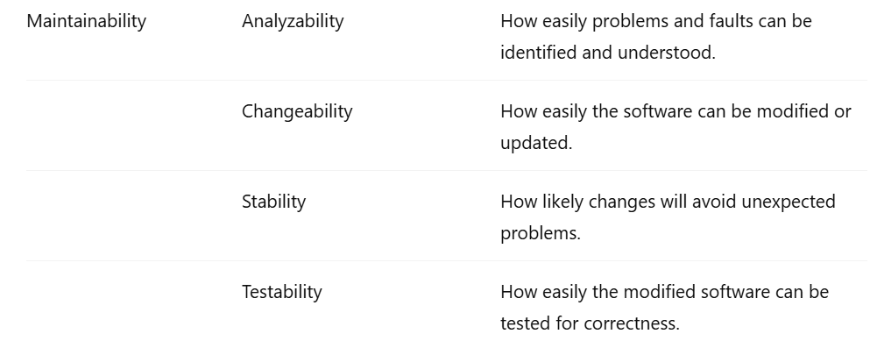
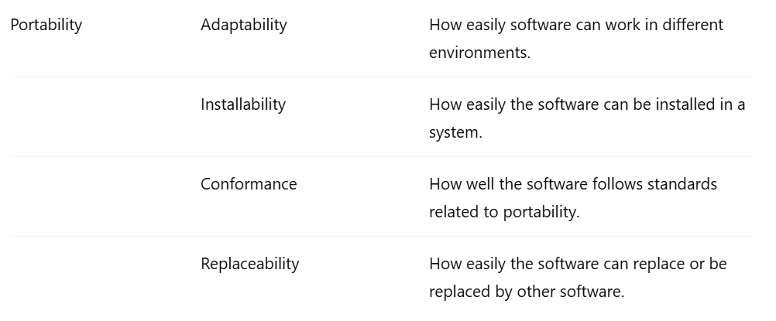

ISO/IEC 25010
- ISO/IEC 25010, which replace ISO/IEC 9126, was issued in March 2011.
- ISO 25010 has eight product quality characteristics (in contrast to ISO 9126's six), adding security and compatibility.
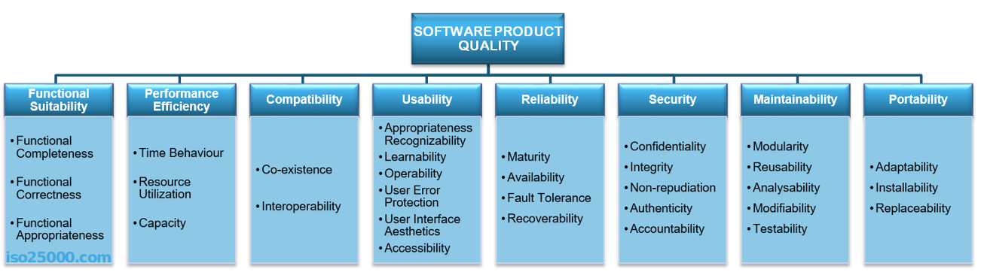
ISO/IEC 25010
ISO/IEC 25010 – Security is a new characteristic added to software quality. Its sub-characteristics are:
- Confidentiality – Only authorized people can access the data.
- Integrity – Data is protected from being changed without permission.
- Non-repudiation – Actions can be proven to have happened.
- Accountability – Actions can be traced back to the person who did them.
- Authenticity – The identity of users or systems can be verified
Lecture 3
Software Defects
Correctness
Meaning:
Correctness means that the software works the way it is supposed to work. It gives the right results and follows the requirements given by the users or developers.
Explanation:
- Correctness is usually the most important part of software quality, especially when people’s daily life or business depends on the software.
- Because of this, we focus mainly on correctness when judging software quality.
- We study quality attributes related to correctness and methods that help ensure and prove that the software works properly and gives accurate results.
Correctness & Defects
Correctness and defects are related to how well the software works and how many problems (errors or bugs) it has.
Relationship:
- If a software system has fewer defects, its correctness is higher.
- If a software system has many defects, its correctness becomes lower.
Explanation:
High-quality software means the system has very few problems or defects while it is running.
If any problem happens, its negative effect should be very small and should not seriously affect the system or users.
Definitions
Key to the correctness aspect of software quality is the concept of defect:
- Error
- Fault
- Failure
“Defect” generally refers to some problem with the software, either with its external behavior or with its internal characteristics.
Error, Fault & Failure
Error:
- An error is a human mistake, misconception, or slip that leads to incorrect data or code.
- Example: A programmer misunderstands the requirement and thinks the formula should be A + B instead of A * B.
Fault:
- A fault, also known as a bug or defect, is the manifestation of an error . A Fault is an incorrect step, process, or data definition in a computer program.
- Example: The programmer writes the code A + B in the program (this incorrect logic is the fault).
Failure:
A failure occurs when a fault is encountered and executed in the operational environment, resulting in the software not performing its required function (e.g., a system crash, incorrect output, or an unresponsive application).
Conclusion: All errors, faults, and failures together are called defects in software studies.
Simple Relationship
Error (human mistake) → Fault (wrong code in software) → Failure (system shows wrong result).
Error, Fault & Failure
- We also include error sources, which are the main reasons or root causes behind mistakes in software development. These reasons can include human misunderstandings, wrong assumptions, or misconceptions about the requirements or the system.
- In software literature, errors, faults, and failures together are called defects.
Bugs
- Software problems or defects are commonly called “bugs.” Bug can be due to error or fault.
- The concepts of error (including error source), fault and failure can be an be understood by looking software artifact (code, Design, documents), software development activities and how the software behaves when people use it
Artifact: An artifact is any item or document created during software development (Source code, Design diagrams, Requirement documents).

Cosmetic Bug
A cosmetic bug is a small visual problem in the software interface that does not affect how the system works, but can have great impact in some contexts.
Example:
- A button text is misspelled.
- A label is not properly aligned on the screen
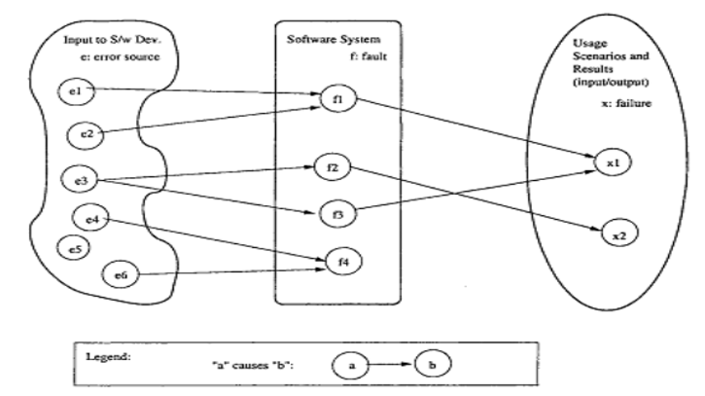
Note: It’s not always compulsory that error cause fault and fault cause failure as show in above figure.
Concepts & Relations Illustrated of Figure
- The software system, shown by its artifacts, is represented by the middle box.
- The artifacts mainly include software code and sometimes other items such as designs, specifications, and requirement documents.
- The faults (defects) that exist inside these artifacts are shown as circled items inside the middle box.
Concepts & Relations Illustrated of Diagram
- The things we use to start software development, shown in the left box, include ideas and information, developers who have certain skills and experience, reusable software parts, and similar resources.
- Different sources of errors are also shown as circles inside this left box.
Concepts & Relations Illustrated of Diagram
- The left box shows the things we use to start making software, like ideas, information, skilled people, and reusable code.”
Concepts & Relations Illustrated
- The right box shows usage examples and execution results. They tell us what goes into running the software, what the software is expected to do, and the final outputs.
- Some of these results may not match what we expect—these are called failures and are shown as circled failure examples.
Concepts & Relations Illustrated
A causal relation exists among these three aspects of defects:
Errors Faults Failures
Errors may cause faults to be injected into the software, and faults may
cause failures when the software is executed.

Concepts & Relations Illustrated of Diagram
However, this relationship is not necessarily 1-to-1:
- An error source, such as e5, may not cause any fault injection, and a fault, such as f4, may not cause any failure, under the given scenarios or circumstances.
- These faults are called dormant (or hidden) faults because they may not cause a problem now but can create errors in different situations.
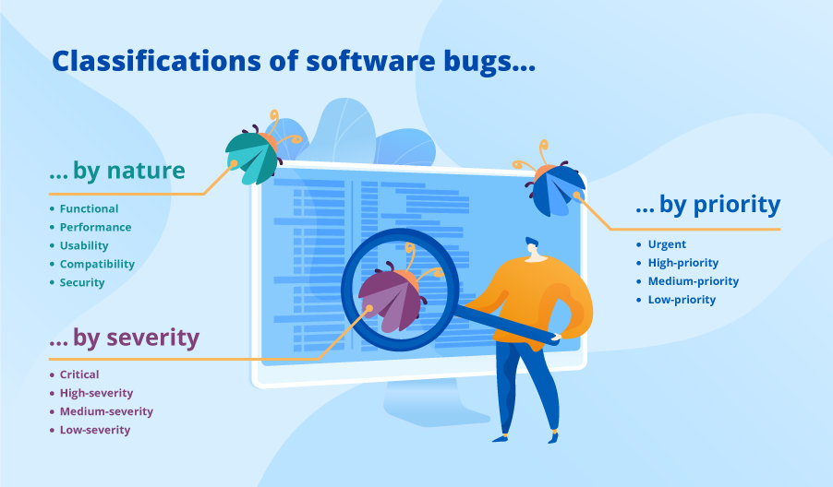
In software testing, bugs (errors in software) can be classified in different ways so developers understand what type of problem it is, how serious it is, and how quickly it should be fixed.
The three main ways are by Nature, by Severity, and by Priority.

Bugs by Nature
We classify by nature to know what type of problem the bug is. This helps developers understand which part of the system is affected.
1. Functional defects
Functional defects are errors that happen when the software does not work according to its required functions. This means the system does not perform the task that it is supposed to do based on the requirements.
These types of defects are usually found during functional testing.
Example:
A functional defect was found in an e-commerce website search system. When a user entered a product ID, the search did not show any results. However, according to the requirements, users should be able to search products using both the product name and the product ID.
2. Performance defects
Performance defects are problems related to the speed, stability, response time, or resource usage of the software. This means the system may work, but it works slowly or inefficiently.
These types of defects are usually found during performance testing.
Example:
A performance defect occurs when a system takes much more time to respond than what is mentioned in the requirements. For example, if the system should respond in 2 seconds but it takes 10 seconds, it is a performance defect.
3. Usability defects
Usability defects are problems that make the software difficult or inconvenient for users to use. These issues reduce the user’s experience and comfort while using the application.
Example:
A usability defect can occur when the content layout is hard to read or navigate, or when the signup process is too long and complicated for users to complete easily.
4. Compatibility defects
Compatibility defects are problems that occur when software does not work properly on different devices, operating systems, browsers, or hardware. This means the application may work correctly in one environment but not work properly in another.
These types of defects are usually found during compatibility testing.
Example:
A mobile app for car insurance claim estimation did not work properly on Android 8.0 and 8.1. The problems included changes in font size, wrong content alignment, and issues with the scroll bar.
5. Security defects
Security defects are weaknesses in the software that can allow hackers or unauthorized users to attack the system or access data. These problems can make the system unsafe and expose important information.
These types of defects are usually found during security testing.
Example:
Examples of security defects include encryption mistakes, buffer overflow problems, and weak authentication (poor login security) that may allow unauthorized access to the system.
Software defects by severity
Severity means how serious or harmful the bug is to the system.
1. Critical defects:
Critical defects are very serious problems that stop the whole system or an important part of the system from working. Because of this, testing cannot continue until the defect is fixed.
Example:
When a user tries to log in to an application, the system shows a server error message, and the user cannot access the system.
2. High-severity defects:
High-severity defects are serious problems that affect important functions of the application, but the system may still run. The software does not behave according to the requirements.
Example:
In a shopping app, the “Add to Cart” button does not work, but browsing products still works.
3. Medium-severity defects:
Medium-severity defects occur when a small or less important function of the software does not work according to the requirements, but the main system still works.
Example:
In a messaging app, the “emoji picker” sometimes doesn’t open, but users can still send text messages and images without any problem.
4. Low-severity defects:
Low-severity defects are small issues that usually affect the appearance (UI) of the application but do not affect how the system works.
Example:
A button in the application appears with a slightly different size or color than expected.

Software defects by Priority
1. Urgent defects:
Urgent defects are problems that must be fixed within 24 hours after they are reported. Usually, defects with critical severity are considered urgent. However, sometimes even a low-severity defect can be treated as urgent if it affects the business or company image.
Example:
If the company’s name is spelled wrong on the application’s home page, it may not affect how the software works, but it can damage the company’s reputation, so it should be fixed quickly.
2. High-priority defects
High-priority defects are the errors that must be fixed in an upcoming release in order to meet the exit criteria (the criteria or requirements which must be met to complete a specific task or process).
Example:
An application is failing to navigate a user from the login page to the home page even though a user has entered valid login data.
Acceptance vs Exit Criteria
Exit Criteria (Acceptance from Org. working on software)
Exit criteria are the conditions that must be met before finishing a testing phase.
Acceptance Criteria (Acceptance from User)
Acceptance criteria are the specific conditions a feature must meet so that the customer or user accepts it.

3. Low-priority defects
Low-priority defects are problems that do not need to be fixed to complete testing (exit criteria), but they should be fixed before the software is released to the public.
Example:
Small issues like spelling mistakes (typos), wrong alignment, incorrect element size, or other UI appearance problems.
Cosmetic Bug
A cosmetic bug is a small visual problem in the software interface that does not affect how the system works, but can have great impact in some contexts.
Example:
- A button text is misspelled.
- A label is not properly aligned on the screen
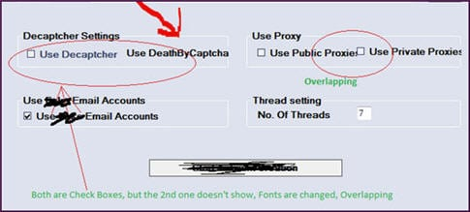
So, What Is Software Quality?
Software quality means how good and reliable a software system is. Different people (like users, developers, or testers) may understand quality in different ways depending on their role.
We adopt the correctness-centered view of quality; high software quality means the software has very few problems or no problems for users.
These problems that users face are usually caused by defects (bugs) inside the software. So, if the software has fewer defects and works correctly, it is considered high-quality software.
Lecture 4
Poor Quality Practices
Poor Quality Practices
- Poor quality is not an inevitable attribute of software that means Poor Quality is not something that must happen in software. It must be removed.
- It can be predicted and controlled, but only if its causes are understood and addressed.
- When software has poor quality, it can damage business value because it may cause loss of customers, money, or reputation.
Reasons for Poor Software Quality
- Lack of domain knowledge
- Lack of technical knowledge
- Unrealistic schedule
- Badly engineered software
- Poor acquisition practices

1. Lack of Domain Knowledge
- It is the biggest reason for poor software quality.
- Developers do not properly understand the business or problem area the software is made for, so the software may not meet real user needs.
- Different business fields (domains) include banking, telecommunications, energy, retail, and supply chain.
- Developers don’t understand the business at the start, so they make mistakes in the software. Later, when they fix those mistakes, they start learning how the business actually works.
2. Lack of Technical Knowledge
The development team does not have enough skills or experience with the required technologies, tools, or programming methods
- Developers need to know different programming languages and technologies.
Modern business software is complex and usually has different parts:
- User interface – what the user sees
- Business logic – the rules and calculations
- Data management – storing and handling data
To avoid problems:
- Cross-train developers in different application technologies.
- Have team members check each other’s work (peer review)
3. Unrealistic Schedule
The project is given too little time to complete, so developers rush their work and mistakes are more likely.
- If developers are rushed to finish software too quickly, the quality usually suffers.
- When working too fast, developers get stressed, make more mistakes, and have less time to fix them.
To avoid this:
- Use good management practices
- Plan carefully and track progress to keep the schedule realistic
4. Badly Engineered Software
The software is poorly designed or poorly structured, which makes it harder to maintain, update, or fix.
- Two-thirds or more of most software development activity involves changing or enhancing existing code.
- If the code is too complex or messy, it’s hard to understand, and making changes can cause more mistakes.
- This can lead to expensive fixes and delayed releases.
To improve:
- Simplify important parts of the code (refactoring)
- Use tools to check code for problems (static code analysis)
5. Poor Acquisition Practices
The organization makes bad decisions when buying or selecting software or development services, which leads to low-quality results.
- Big software projects are often built by teams in different places.
- The organization may have little control or knowledge about the quality of the software they get.

To prevent problems:
- Managers should set quality goals in contracts
- Have a strong quality check before accepting the software
User Perspective
External view: How the software looks and works to the user.
- Users mainly care that the software runs correctly and has few or no errors.
- If errors happen, they should cause as little trouble as possible.
Note: Quality does not mean just the output its complete project including Documentation, Design and Backend etc.
Properties & Related Measurements
- Failure properties: These tell us what kind of errors happen, how they happen, and when.
- Direct failure measurement: We can measure these properties directly by looking at how many failures happen, where they occur, and how bad they are.
- Failure likelihood: This shows how often a failure might happen. Users care a lot about this.
- Reliability measurement: Reliability tells us the chance that software will run without errors for a certain time or for certain inputs.
- Failure severity measurement: This tells us how serious a failure is. Users worry more if a failure can cause big problems or damage.
- Safety assurance: Very serious failures (accidents) must be avoided or controlled to keep people safe and reduce other damages.
Organization Perspective
Internal view: How the software looks to the company or developers.
- The organization needs to find and fix the problems that caused software failures.
- They should collect and study information about each fault and also look at all faults together to prevent future issues.
Organization Perspective Cont.…
- Individual faults: Each problem can be studied based on its type and how it caused a failure or accident.
- Collective analysis: All faults together can be studied to see where and when most problems happen in the software and during development.
Defects in the Context of SQE
For most software development organizations, ensuring quality means dealing with defects.
Three main techniques to ensure quality:
- Defect prevention
- Defect detection and removal
- Defect containment
Defects in Context of SQE
1. Defect Prevention:
- Stop problems from happening in the first place.
- Remove the cause of errors before they enter the software.
2. Defect Detection & Removal:
- Find problems that have already happened.
- Fix these problems to prevent failures.
3. Defect Containment:
- Keep problems limited to a small part of the software.
- Reduce the damage caused by failures.
Defect Prevention
- We can study why people make mistakes and fix the root causes. This is called error-source removal.
- The focus of these activities is typically on the people and their conceptual mistakes, which may lead to the selection and use of inappropriate development methodologies, languages, algorithms, QA strategies, etc.
- Such inappropriate selection may lead to numerous fault injections.
Defect Detection & Removal
Static Testing: Checking the software without running it.
1. Reviews:
- Carefully examine documents, code, or design with a team.
- Goal: Find and fix errors early.
2. Walkthroughs:
- Go through documents with peers or managers to spot mistakes.
3. Desk Checking:
- Manually check the logic of an algorithm on paper without using a computer.

Defect Detection & Removal
Dynamic Testing: Testing the software by running it with test cases.
1. White Box Testing:
- Tester knows the internal code or design.
- Tests are done based on the structure of the program.
2. Black Box Testing:
- Tester does not know the internal code or design.
- Tests are done based on inputs and expected outputs.
3. Grey Box Testing:
- Tester knows some parts of the internal code or design.
- Combines both white box and black box approaches.
Defect Containment
- Fault tolerance: Stop small problems (faults) from causing big failures. This way, local faults don’t crash the whole system.
- Failure containment: Take steps to prevent serious consequences, like accidents, injuries, or major damage if a failure happens.
Some Key Term
Safety
- Protects people and systems from accidents/ Unintentional or harm.
- Usually caused by mistakes or failures.
- Goal: Keep people and equipment safe from danger.

Security
- Protects data, software, and systems from intentional attacks or misuse.
- Usually caused by malicious actions
- Goal: Keep information and resources safe from attackers.
Important Question for Exam: Write About the three basic techniques of SQA?
Lecture 5
Quality Laggards
Quality Assurance Organizations
- No quality assurance 60%
- Token/Formality quality assurance 20%
- Passive quality assurance 15%
- Active quality assurance 5%
Software Quality in Sub-Industries
Systems software that controls physical devices.
Software that controls machines or hardware, like medical machines, cars, or factory equipment. It must be very reliable because errors can cause damage or accidents.
Information systems that companies build for their own use.
Software that companies make to manage their daily work, like payroll, inventory, or employee data. Good quality helps the company work smoothly.

Commercial software built by vendors for lease or sale.
Software that companies create to sell to customers, like office or accounting software. It should be easy to use and work properly for many users.
Military software built following various military standards.
Software made for army or defense systems. It must follow very strict rules and be extremely dependable.
End-user software built for private use by computer-literate workers or managers.
Small software or tools made by employees or managers for their own work, such as spreadsheets or simple programs to solve their personal work tasks.
Quality Laggards
Quality Laggards are organizations that do not focus on software quality and use very few or no quality assurance practices.
No software quality measurement program of any kind.
- Don’t know current status of quality within organization.
- Don’t know whether quality is improving, getting worse, or staying the same.
No usage of formal design and code inspections.
- Checking and reviewing the design and code helps find and fix errors early.
No knowledge of defect potential and defect removal efficiency
- Defect potential means how many errors a software product may contain.
- Defect removal efficiency means how well those errors are found and fixed before giving the software to customers.
Either no quality assurance group or a group that is severely understaffed.
- The organization either has no QA team or has very few people in the QA team.
- The QA team exists only for formality, not for doing proper quality work.
No trained testing specialists available.
- For large projects, specialist or trained specialist always required.
- Must write test cases and conduct to find error.
Few or no automated quality assurance tools.
- Maybe they have but they don’t use.
- Tools can help to improve quality.
No quality and reliability estimation capability.
- Whenever you have an active SQA program, you must require measurements and estimations based on previous data.
- If a company does proper QA, it should measure quality and use past experience to predict how reliable the software will be.
Minimal or no software project management tools available.
- The organization has few or no tools to plan, track, or manage software projects.

No automated risk assessment or avoidance capability.
The organization cannot automatically find or handle potential problems (risks) in the project.
- How risk can be avoided.
Risks can be prevented by careful planning and taking safety steps in advance.
- Risk control and monitoring.
Risks should be watched closely and managed so they don’t cause big problems.
No plan for testing activities.
The organization does not plan how and when software will be tested.
- Testing phase may run number of times.
They may test the software many times in a random way, not in an organized manner.
- May not be properly documented.
Results of testing and what was done are often not written down clearly.
No complexity analysis tools utilized.
The organization does not use tools to check how complicated the software is.
- Complexity in design and code.
The software’s design or code may be too complicated, making it hard to understand, test, or maintain.
- Cyclomatic Complexity.
A method to measure how complex a program is, by counting the number of different paths through the code.

Defects repair rates are low.
- They fix very few errors or bugs in the software, so problems often remain.
Executive and managerial indifference (and ignorance) of quality matters.
- Managers don’t care or don’t understand the importance of software quality, so quality is ignored.
- Usually Due to conflicts.
Important Question for Exam: Why Product Cancellations? (Ans: Above Quality Laggards)
Related Issues/ Problems Caused by Poor Software Quality
Staff morale
People are unhappy or frustrated at work.
Ready to take other opportunities
Employees may want to leave the company for better jobs.
Market shares and competitive positioning
Poor quality can make the company lose customers and fall behind competitors.
Indication to change their work
Problems in quality may force the company to improve or change how they work.
Company may need to recall their products
If software is very bad, the company might have to take it back from customers.
Product cancellation
Sometimes the company may stop or cancel a product completely due to poor quality.
Quality Attributes
Quality attributes are the important features that decide how good a software is, how it works, and how easy it is for people to use.
They affect:
- How the software works (speed, reliability)
- How it is built (easy to maintain, scalable)
- How users experience it (easy to use, safe)
Common Quality Attributes
Categories of Quality Attributes
- Product Specific
- Organization Specific
Product Specific
Ease of Use
- Usability means how easy and comfortable the software is for users.
- The software should be user-friendly, meet user needs, and work well for disabled users.
- A good usability gives a positive overall experience.
Documentation
- Documentation should be clear and easy to understand.
- It should be available whenever needed, preferably online.

Defect Tolerance
- Some errors or bugs are acceptable, like small cosmetic issues that don’t affect functionality.
- Impact of defects: Any defects that affect users must be identified and fixed.
- There should be a program to remove defects from the software.
Performance
Performance shows how fast the software responds when a user does something.
Measured by:
- Latency – Time taken to respond to an action or event.
- Throughput – How much work the system can handle in a given time.
Manageability
- Manageability is how easy it is for administrators to handle and control the software.
- The software should provide tools to monitor, debug, and improve performance (like show system status, error or resource usage).
Defect Frequency
- Some defects can be accepted only if they happen rarely or for a short time (text editor sometimes changes font size briefly).
Packaging
Packaging refers to how the software is delivered and installed, making it easy for users to set up and use.

It includes:
- Installer programs (like .exe or .msi)
- Setup instructions
- Necessary files and resources bundled together
Important Question for Exam: What is meant by Packaging of software.
Security
- Security means the software can protect itself and its data from hackers or mistakes.
- It prevents unauthorized access, changes, or loss of information.
- A secure system keeps important data safe.
Reusability
- Reusability means parts of the software can be used in other programs or projects.
- This saves time and avoids rewriting the same code.
Organization Specific Attributes
Service and Scope
These are about how the company supports the software after giving it to customers.
Includes:
- After-delivery support – Helping customers with problems or questions.
- Speed of updates – How quickly new features or improvements are provided.
- Speed of defect repair – How fast bugs and errors are fixed.
Internal Processes
These are about how the company develops the software.
Includes:
- Controls – Rules to ensure quality during development.
- Techniques – Methods used to build software efficiently.
- Frameworks – Predefined structures or templates for development.
- Procedures – Step-by-step instructions followed by the team.
Maintainability
- How easy it is for the company to update, fix, or improve software after release.
Scalability
- How well the company’s software can handle more users or bigger workloads as needed.
Training and Knowledge Management
- How well the company trains staff and shares knowledge to maintain high-quality software.
Compliance and Standards
- Following industry standards, legal requirements, or internal quality standards.
Risk Management
- How well the organization identifies, monitors, and controls risks during software development and after release.

Important Question for Exam: Explain the quality attributes of software, highlighting both product-specific and organization-specific attributes
Achieving High Levels of Software Quality
Software Quality Management involves:
- Defining quality goals for the software products.
- Establishing plans to achieve these goals.
- Monitoring and adjusting the software plans, activities and quality goals to satisfy the needs of the customer/end user for high quality products.
Lecture 6
Cost of Software Quality
Cost of Software Quality
The financial evaluation of the quality of software during development and maintenance.
It is a type of software quality metric where money (financial cost) is used to measure software quality.
Note: Cost doesn’t only mean money its about men power, time and effort overall.
Cost of Software Quality
- There are about ‘Y errors’ per 1000 lines of code
- It takes about ‘Z minutes’ to find each error
- It takes about ‘U hours’ to fix each error

- There are about ‘5 to 15 errors’ per 1000 lines of code
- It takes about ‘75 minutes’ to find each error
- It takes about ‘2 to 9 hours’ to fix each error
Cost of Software Quality
Cost of Conformance (Cost to avoid Failures)
It is the money spent during the project to prevent errors and make sure the software has good quality.
Cost of Non-Conformance (Cost to remove Errors)
It is the money spent during or after the project to fix problems that happen because of poor quality.
Cost of Quality (COQ) calculation
COQ = Cost of Conformance + Cost of Non-Conformance (or failure costs)
Objective
Managers control the cost of software quality by comparing the current performance with different cost values, such as:
- Budgeted control costs
(Money planned for SQA prevention and appraisal activities)
- Failure costs from the previous year
- Quality costs from previous projects
- Quality costs from other departments
In simple words:
Managers check current quality costs and compare them with past costs or planned budgets to see if the software quality process is working well.

The Classic Model of Cost
The model classifies costs related to product quality into two general classes:
Control Costs (Cost of Conformance)
These are the costs spent to prevent and detect software errors so that the number of errors is reduced to an acceptable level.
Failure of Control Costs (Cost of non-Conformance)
These are the costs spent when errors are not prevented or detected, which leads to software failures and extra fixing costs.
Classic Model
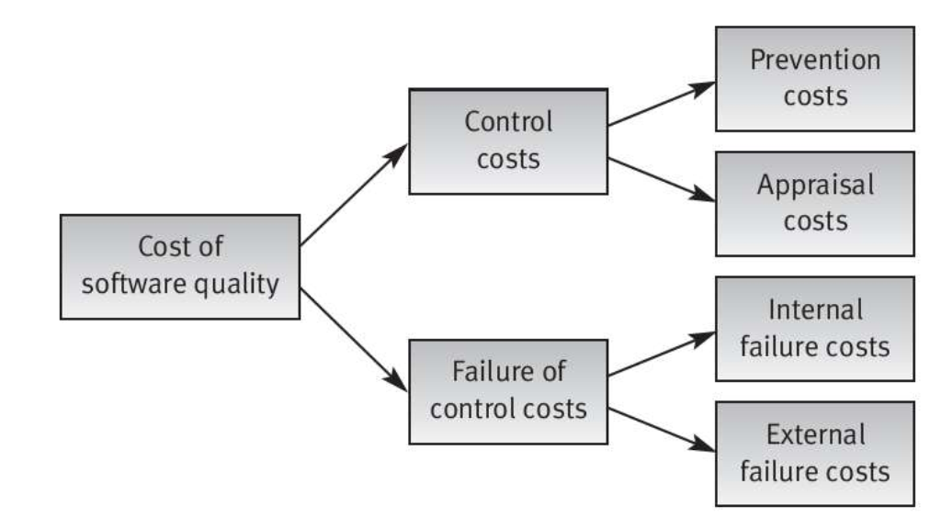
Control costs
- Prevention costs
Prevention costs are the money spent on building a strong quality system and doing quality activities that help the whole organization, not just one project.
- Appraisal costs
Appraisal costs are spent on finding software errors in a specific project or system.
Prevention Cost
Money spent on stopping mistakes before they happen by improving or updating infrastructure, such as:
- Writing clear steps and instructions for work (procedures and work instructions)
- Using helpful tools like templates, checklists, or other support items
In short: Prevention costs are for preparing and improving the system so errors are less likely to happen.
Prevention Cost
Regular implementation of SQA preventive activities:
- Teaching new employees about software quality rules and procedures for their job.
Control of the SQA system through performance of:
- Internal quality reviews – checking the work inside the company to make sure it meets quality standards
- External audits and certifications – letting customers or official organizations check the system and give quality approval
Appraisal Cost
Appraisal costs are spent on finding software errors in a specific project or system.

Typical appraisal costs include:
Reviews:
- Formal design reviews (DRs) – checking the software design carefully to find problems.
- Peer reviews (inspections and walkthroughs) – team members check each other’s work to detect mistakes.
- Expert reviews – experienced specialists review the system to identify possible errors.
Appraisal Cost
Costs spent on testing the software to find errors.
Types of testing costs include:
- Unit tests – testing small parts of the program (individual functions or modules).
- Integration tests – testing how different parts of the software work together.
- System tests – testing the complete software system to check if everything works correctly.
- Acceptance tests – testing done by the customer (or with the customer) to confirm the software meets their requirements.
Failure of Control Costs (Cost of non-Conformance)
These are the costs spent when errors are not prevented or detected, which leads to software failures and extra fixing costs.
- Internal failure costs
- External failure costs

1. Internal failure costs
Internal failure costs are the costs of fixing software errors that are found during design reviews, software testing, or customer acceptance testing.
These errors are detected and corrected before the software is delivered or installed at the customer’s site.
2. External Failure
External failure costs are the costs of fixing software errors that are found after the software has been delivered and installed at the customer’s site.
These errors are usually reported by customers or discovered by the maintenance team.
Internal Failure Costs
Internal failure costs are the costs of fixing software errors that are found during design reviews, software testing, or customer acceptance testing.
These errors are detected and corrected before the software is delivered or installed at the customer’s site.
Typical internal failure costs include:
- Costs of redesign or design corrections after problems are found during design reviews or testing.
- Costs of re-programming or fixing code when errors are found in tests.
- Costs of repeating design reviews and testing (regression testing) to make sure the corrected software works properly.

External Failure Cost
External failure costs are the costs of fixing software errors that are found after the software has been delivered and installed at the customer’s site.
These errors are usually reported by customers or discovered by the maintenance team.
Typical external failure costs include:
- Handling and solving customer complaints during the warranty period.
- Paying compensation or damages to customers if a serious software failure occurs during normal use.
Extended Model
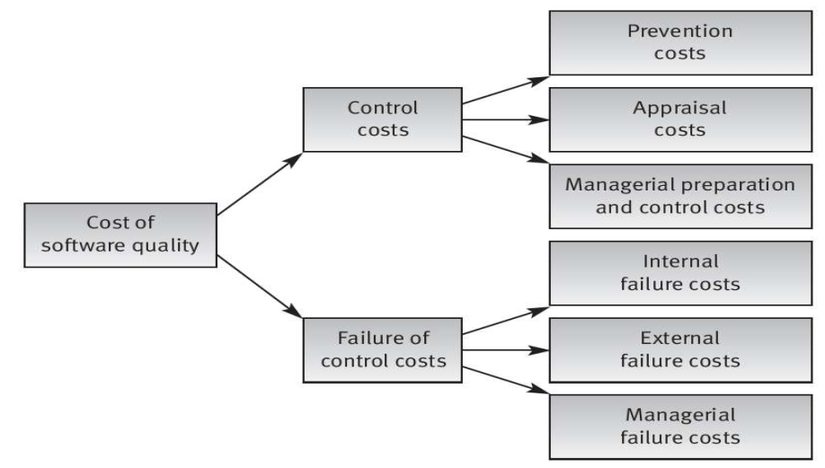

Managerial Cost
Managerial costs are the expenses involved in planning, supervising, and controlling activities to avoid management errors or lower the likelihood of such errors occurring.
Scenario: Managing a Software Project
A software company is making a new app. To avoid mistakes and delays:
- Planning & Scheduling: The manager makes a project plan, sets deadlines, and assigns tasks.
- Code Reviews & Guidelines: Managers check developers’ work and give rules to avoid bugs.
- Risk Assessment: They look for possible problems (like server issues or security risks) and make backup plans.
- Training & Meetings: Managers train the team on new tools and hold meetings to guide them.
The money spent on these activities — salaries, meetings, training, and planning — is managerial cost because it helps prevent mistakes before they happen.
Managerial Cost
- Contract Reviews: Money spent checking proposals and contract drafts before final approval.
- Project Plans: Money spent making project and quality plans and reviewing them.
- Plan Updates: Money spent updating project and quality plans regularly.
- Progress Control: Money spent monitoring software development work to make sure it’s on track.
Managerial Failure Cost
- Extra costs that happen because the company underestimated resources needed in the proposal (hidden or unplanned costs). For example, A company said it would finish an app with 3 developers in 2 months, but it needed 5 developers → extra cost.
- Money paid to customers as compensation for delivering the project late, caused by an unrealistic schedule in the company’s proposal. For example, promised delivery in June, delivered in August → paid compensation to the client.
Unplanned or Hidden Cost
Hidden or unplanned cost is basically money a company has to spend that they didn’t expect when making the plan or proposal.
- Hidden cost: Something you didn’t realize would cost money at first.
Example: You promised a software project would need 3 developers, but later realize extra testing requires hiring 2 more → extra cost.
- Unplanned cost: Money spent on things you forgot to include in the plan.
Example: Buying a new server because the old one can’t handle the project → extra cost.
Q: Consider a scenario
“If a software project is delivered late to the customer, does this situation fall under Managerial Failure Cost?”

Yes — delivering software late to a customer is a Managerial Failure Cost. Here’s why:
- Reason: The delay happens because of poor planning, underestimation of time/resources, or unrealistic schedules in the proposal.
- Effect: The company may have to pay compensation to the customer or face extra costs due to the delay.
- Key point: This is reactive, not preventive — it’s the cost of a management mistake.
Cost of Quality (COQ) calculation
COQ = Cost of Conformance + Cost of Non-Conformance (or failure costs)
Cost of conformance = sum of the prevention, appraisal & managerial costs.
Cost of non-conformance = sum of internal failure, external failure & managerial failure costs.

Lecture 7
Software Quality Assurance (SQA)
Quality Assurance
Quality assurance can be defined as, “setting up proper rules, procedures, and standards in an organization to make sure the software is of high quality.”
Quality assurance is responsible for managing quality. The word “assurance” means that if all the correct processes and steps are followed, then management can be confident that the final software product will be of good quality.
About Quality Assurance
- The first formal quality assurance and control function was introduced at Bell Labs in 1916.
- During the 1950s and 1960s, the programmers controlled their product quality.
- During the 1970s, quality assurance standards were first introduced in military related software development.
Software Quality Assurance
Software Quality Assurance can be defined as, “a planned and systematic set of activities that are done to make sure the software is of high quality.”
Functions of Quality Assurance
To maintain standards and specifications for raw materials and finished products.
→ Make sure everything meets quality requirements.
To support the company in quality-related areas like troubleshooting, production, design, and training.
→ Help improve product quality and train the team.
To produce accurate, reliable, and useful information.
→ Ensure correct and trustworthy data.
SQA Activities
SQA is composed of a variety of tasks associated with two different constituencies:
- Software engineers: perform technical work.
- SQA group: responsible for quality assurance planning, defect’s record keeping, analysis and reporting.
Elements of SQA
- Standards
- Error/defect collection and analysis
- Reviews and Audits
- Testing
- Security management
Role of SQA Group
Prepares an SQA plan for a project
- The quality plan is created at the start when the project is being planned.
- It controls and guides all quality-related activities of both developers and the SQA team.

The SQA Plan
- Evaluations to be performed:
What things will be checked to make sure the software is working correctly.
- Audits and reviews to be performed:
Checking and reviewing the work regularly to find mistakes and improve quality.
- Standards that are applicable to the project:
Rules and guidelines that the project must follow.
- Procedures for error reporting and tracking:
Steps for reporting bugs/errors and keeping track of them until they are fixed.
- Documents to be produced by the SQA group:
Reports and documents that show quality checks, results, and improvements.
- Amount of feedback provided to the software project team:
How much and how often the team will receive feedback about their work.
The SQA Plan
- The SQA plan gives a clear guide on how to apply quality assurance in the software project.
- It works like a template that shows what quality activities should be done in every software project.
IEEE SQA Plan
- The purpose and scope of the plan:
Explains why the plan is made and what areas of the project it covers.
- A description of all software engineering work products:
Details about all outputs like documents, code, and reports created during development.
- All applicable standards and practices that are applied during the software process:
The rules and best practices that must be followed while developing the software.
- SQA actions, tasks and their placement throughout the software process:
What quality tasks will be done and when they will be performed during the development process.
IEEE SQA Plan
- The tools and methods that support SQA actions and tasks:
The software tools and techniques used to help perform quality assurance activities.
- Software configuration management procedures for managing changes:
The steps used to control and manage changes in the software.
- Methods for assembling, safeguarding and maintaining all SQA-related records:
How quality documents and records are collected, stored, and kept safe.
- Organizational roles and responsibilities relative to product quality:
Who is responsible for ensuring software quality in the project and what their duties are.

Role of SQA Group
The SQA group checks the software process to make sure it follows company rules, internal standards, external standards (like ISO-9001), and the project plan.
Role of SQA Group
Reviews software engineering activities to verify compliance with the defined software process.
- Identifies, documents and tracks deviations from the process and verifies that corrections have been made.
- It regularly shares reports about its work with the project manager.
Actual Cost of Software Quality
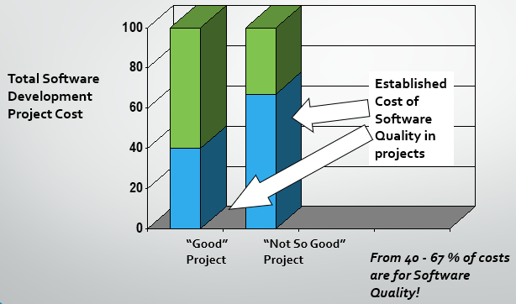

Economics of Software Quality
Good quality software is completed faster because it has fewer errors. It does not face many problems during integration and testing, so the development process is smoother and quicker compared to low-quality software.
Economics of Software Quality
High-quality software sells more in the market because users are more satisfied with it. This leads to better reviews and a larger market share compared to low-quality software.
Economics of Software Quality
Good quality software costs less to build and maintain because it has fewer bugs. Fixing errors takes a lot of time and money, so when there are fewer mistakes, the overall cost becomes lower.
Economics of Software Quality
High quality software applications have better reliability levels and longer average times to failure than low quality applications.
Economics of Software Quality
High-quality software projects make employees more satisfied and motivated. Because the work goes smoothly with fewer problems, employees feel happier compared to low-quality projects.

Lecture 8
Quality Requirements
Requirements
What the machine should do
- Input
- Output
- Interface
- Response to events
Criteria (3C)
1. Correctness
Requirements should be true and accurate.
Example: If the system says “login with username and password,” it should actually work that way.
2. Consistency
Requirements should not conflict with each other.
Example of inconsistency:
- Requirement 1: System works offline
- Requirement 2: System needs internet to work
3. Completeness
All-important requirements should be fully written and included.
Nothing important should be missing.
Example: If we are making a school system, we must include:
- Student info
- Teacher info
- Attendance
- Marks system
Quality Requirements
Specify not the functionality of the system, but the quality with which it
delivers that functionality.
Should be measurable (quantified)
- Try to give numbers or clear limits (e.g., “response time under 2 seconds”).
- They should be testable, so we can check if the system meets them or not
Very important (sometimes more than functional requirements)
- Even if features are correct, poor quality can make the system useless.
- Good quality design can reduce problems caused by missing features.
- If performance, speed, or reliability is poor, users will not use it.
Example Quality Requirements
- Performance → System should run efficiently and fast.
- Response Time → System should reply within a few seconds.
- Reliability → System should work without frequent failures.
- Visual appeal / usability → System should be easy and attractive to use.
- Scalability → System should handle more users/data without issues.
- Security → System should protect data from unauthorized access.
- Ability to change → System should be easy to modify or update.
- Code quality → Code should be clean, readable, and well-structured.
Other Requirements
Legal requirements
The system must follow all laws and legal rules.
Standard compliance
The system must follow required standards and guidelines.
Implementation requirements
It must specify technical details like programming language, platform, or tools used.
Delivery requirements
It must define how the system will be delivered, in what format, and by which date, including documentation.
Challenges
Stakeholders don’t know what they want
Users are not sure about their needs.
Example: They say “make it good” but cannot explain how.
Hard to explain needs
People cannot clearly say what they want.
Example: They know the idea but cannot describe it properly.
Don’t know cost
They ask for many features without knowing cost or effort.
Example: Asking for very advanced features in a small budget.
Domain knowledge issues
Users don’t understand technical side well.
Example: A doctor knows medicine but not software terms.
Use difficult words (jargon)
They use special words that developers don’t understand.
Example: Using office or field terms without explaining.
Forget basic things
They don’t mention simple things because they think it is obvious.
Example: Forgetting login feature in a system.
Conflicts
Different people want different things.
Example: One group wants strict rules, another wants freedom.
Politics
Some people add requirements for personal benefit.
Example: A manager adds features to increase control.
Managers want more control
Managers add extra steps so they stay involved.
Example: Adding approval steps for every task.
Impact of Low-Quality Requirements
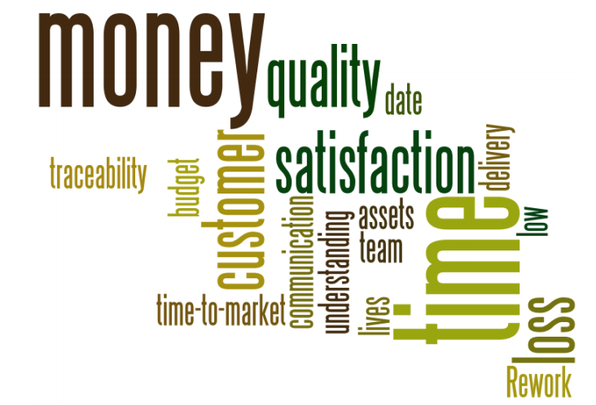
Impact of Low-Quality Requirements
In some cases
- A good requirement specification may lead to a bad project outcome.
But clearly, in every case
- A bad requirement specification will always lead to a bad project outcome.
- Unsuccessful project
Impact of Low-Quality Requirements
Chaos report and some other surveys (e.g. PMI: Pulse of the profession study):
[“40%-70% of defects in the projects are related to requirements. ”]
Capers Jones:
[“The average rework is over 40%-50%.”]
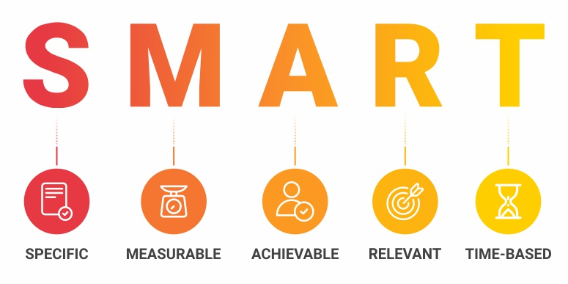

SMART Criteria
S – Specific
The requirement should clearly describe what exactly needs to be improved in the software.
Example: Improve login page speed.
M – Measurable
We should be able to measure the improvement using numbers or indicators.
Example: Login should take less than 2 seconds.
A – Achievable
The goal should be possible to complete with available time, tools, and resources.
Example: Improve performance using optimization techniques that are realistic.
R – Relevant / Realistic
The requirement should be useful and related to the system’s purpose, and achievable in real conditions.
Example: Improving response time is important for better user experience.
T – Time-based
There should be a clear deadline for completing the improvement.
Example: Improve system performance within 2 months.
Requirement Authoring-Quality Checking
Requirements error costs are high
- Fixing requirements after delivery may cost up to 100 times more than fixing in the requirements definition stage.
Training, best practices and verifying requirements by reviewers can help to get SMART requirements:
- But the process is still costly and time consuming.
Quality Checking
Experience shows that about 25% of system requirements are critical and can be improved in writing and clarity.
Common problems found in requirements are:
10–15% forbidden words
- Words that should not be used because they are unclear (like fast, easy, user-friendly without measurement)
15% subject / multiple objects / design issues
- Requirements are not clear about who or what is involved, or they include design details instead of requirements
50% incorrect grammar
- Half of the requirements have grammar mistakes, making them hard to understand
Quality Checking
- Correct – right and accurate requirements
- Unambiguous – clear, only one meaning
- Complete – all requirements included
- Consistent – no contradictions
- Ranked – prioritized by importance
- Verifiable – can be tested
- Modifiable – easy to change
- Traceable – can be linked to source and design changes
Quality Checking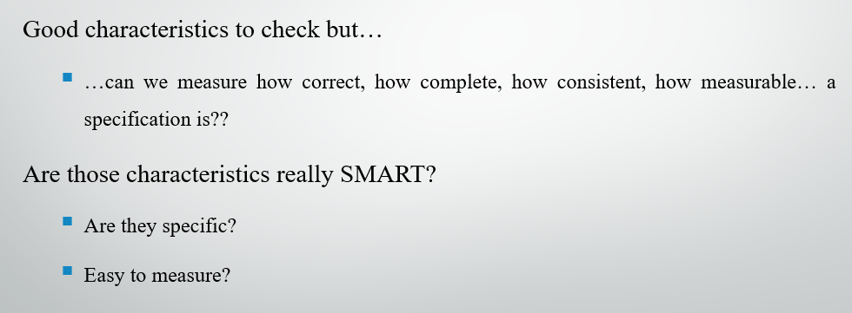
SRE vs SQE
SRE (Software Requirements Engineering)
- Focuses on writing and defining requirements
- Collects what the system should do
- Works mainly in early stage of project
- Example:
“What features should the software have?”
SQE (Software Quality Engineering / QA role)
- Focuses on checking requirements and ensuring quality
- Reviews requirements before final approval
- Creates test cases based on requirements
- Works from early stage to final testing
SRE vs SQE
- QA (SQE) helps in planning quality activities in an organized way.
- This means QA is not only for testing at the end, but also involved in early planning.
Changing Requirements
- The first working demo version of the software leads to change requests or bug reports from the client.
- The new or changed requirements at this stage are managed using a Change Request Template.
- Bugs must be fixed because they are errors in the agreed system (scope errors) that were promised to be delivered in correct form.
Important Question: Write the Quality Requirements according to the SMART criteria.
Lecture 9
SQA Process Implementation Activities
Software Quality Assurance (SQA) Process Implementation Activities are the structured steps taken to ensure that software development and maintenance processes produce high-quality, reliable, and maintainable software.
SQA focuses not just on testing the product but on ensuring the processes themselves support quality.
1. Defining Quality Standards and Procedures
- Set clear quality standards for software and development processes (for example: ISO 9001, ISO/IEC 25010).
- Define rules for coding, design, and documentation so everything follows a proper structure.
- Write down policies, procedures, and checklists so they can be followed in the same way every time.
2. Quality Planning
Develop a Software Quality Assurance Plan (SQAP)
- Scope of QA activities
Define what parts of the project will be tested and checked for quality (what is included and what is not included in QA).
- Responsibilities of QA team members
Assign clear roles to each QA member so everyone knows what tasks they have to perform (like testing, reviewing, reporting bugs).
- Schedules and milestones for reviews, audits, and testing
Set a timeline for when quality checks, code reviews, audits, and testing will be done during the project.
- Tools and techniques for quality measurement
Select the tools and methods that will be used to measure software quality (like testing tools, checklists, and performance metrics).
3. Process Definition and Standardization
- Define software development lifecycle processes (e.g., waterfall, agile)
Decide which development model will be used (like Waterfall or Agile) to guide how the software will be built step by step.
- Standardize workflows for requirements, design, coding, and testing
Set fixed rules and steps for all activities so that every phase (requirements, design, coding, testing) is done in a proper and consistent way.
- Establish configuration management for version control and traceability
Use a system to manage different versions of the software and keep track of all changes so that nothing is lost and everything can be traced easily.
4. Training and Awareness
Train team members in quality procedures, standards, and tools
Teach team members how to follow quality rules, standards, and how to use testing and QA tools.
Promote a quality culture across development, testing, and management teams
Encourage everyone to focus on quality in all work so that developers, testers, and managers all care about making better software.
Ensure all stakeholders understand their roles in SQA
Make sure everyone involved in the project knows what their job is in software quality assurance and what they are responsible for.
5. Reviews and Audits
- Conduct reviews at multiple levels:
Check the software work at different stages to make sure everything is correct and clear.
- Requirements review
Review the requirements to make sure they are complete, correct, and understood properly.
- Design review
Check the design to ensure it properly supports the requirements and is well planned.
- Code review
Examine the code to find errors, improve quality, and ensure it follows standards.
- Test plan review
Review the test plan to make sure all features will be properly tested.
- Perform audits to ensure process compliance and adherence to standards
Do official checks to ensure the team is following all rules, processes, and quality standards correctly.
6. Testing Process Implementation
Implement structured testing processes:
Follow a proper and organized testing method to check software step by step.
Unit testing
Test small parts (modules/functions) of the software individually to make sure each one works correctly.
Integration testing
Test how different modules work together to ensure they are properly connected.
System testing
Test the complete system as a whole to check if everything works properly.
Acceptance testing
Test the software with users or clients to confirm it meets their needs and requirements.
Track defects systematically and ensure proper resolution
Record all bugs in an organized way, fix them properly, and make sure they are fully resolved.
7. Metrics Collection and Analysis
- Collect process and product metrics such as:
Gather important data to measure software quality and development performance.
- Defect density
Measure how many bugs are found in a certain size of software.
- Test coverage
Check how much of the software code or features have been tested.
- Mean time to failure
Find the average time the software runs before it fails or shows an error.
- Process compliance rates
Check how well the team is following the defined rules, processes, and standards.
- Analyze metrics to identify areas for process improvement
Study the collected data to find problems and improve the software development process.
8. Corrective and Preventive Actions (CAPA)
- Identify root causes of defects or process deviations
Find the main reason why errors or problems happened in the software or process.
- Implement corrective actions to fix immediate issues
Take quick actions to fix the current problems or bugs in the system.
- Take preventive actions to avoid recurrence in future projects
Make improvements in the process so the same problems do not happen again in future projects.
9. Continuous Process Improvement
- Periodically evaluate the effectiveness of the SQA process
Regularly check how well the software quality assurance process is working and whether it is useful.
- Update standards, procedures, and tools based on lessons learned
Improve rules, steps, and tools by using experience from past projects and mistakes.
- Incorporate feedback from audits, metrics, and stakeholder reviews
Use suggestions and feedback from audits, data reports, and team members to make the process better.
In short: SQA process implementation is about planning, defining, monitoring, measuring, and improving software development processes to ensure the final software meets quality expectations.
Important Question: Flowchart of above steps
Lecture 10
Software Quality Plan (SQP)
Software Quality Plan (SQP)
A Software Quality Plan (SQP) is a document that explains the quality checking activities, rules, responsibilities, and procedures used to make sure that the software works properly and meets the given requirements and standards.
1. Introduction
1.1 Purpose
This Software Quality Plan explains the quality checking activities, standards, procedures, and responsibilities used to make sure that the software meets customer needs and organizational standards.

1.2 Scope
This plan applies to the development, testing, deployment, and maintenance of the software system to ensure quality is maintained at every stage.
1.3 Definitions
- SQA – Software Quality Assurance
- QC – Quality Control
- Verification – Are we building the product, right?
- Validation – Are we building the right product?
2. Reference Documents
- Software Requirements Specification (SRS)
- Project Plan
- Design Documents
- Test Plan
- Coding Standards
3. Management
3.1 Organization Structure
- Project Manager
- QA Manager
- Developers
- Testers
- Configuration Manager

3.2 Responsibilities
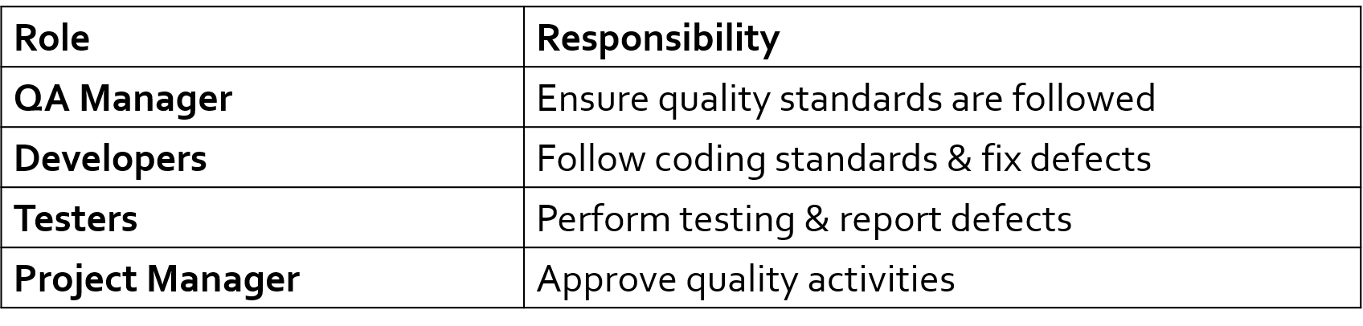
4. Documentation
The following documents will be produced and reviewed:
- SRS
- Design Document
- Test Cases
- User Manual
- Maintenance Guide
- All documents will be version-controlled.
5. Standards, Practices, and Conventions
- Coding standards (e.g., naming conventions, formatting)
- Documentation standards
- Review procedures
- Compliance with organizational or industry standards
6. Reviews and Audits
- Requirements Review
- Design Review
- Code Review
- Test Case Review
- Quality Audits

7. Testing Strategy
7.1 Levels of Testing
- Unit Testing
- Integration Testing
- System Testing
- Acceptance Testing
7.2 Testing Methods
- Black-box testing
- White-box testing
- Regression testing*
*Regression testing verifies that recent code changes—such as updates, enhancements, or bug fixes—have not negatively impacted existing, previously working functionality
8. Problem Reporting and Corrective Action
- Defect tracking system
- Severity classification
- Root cause analysis
- Corrective & preventive actions
9. Tools and Techniques
- Testing tools
- Static code analysis tools
- Project management tools
10. Quality Metrics
Examples:
- Defect density
- Cost of Quality (CoQ)
- Mean Time to Failure (MTTF)
Objectives of Software Quality Plan
- Ensure product meets requirements
- Reduce defects
- Improve reliability
- Ensure customer satisfaction
- Control project risks
Lecture 11
Software Measurements
Basic Terminologies
MEASURE:
A measure is a simple number that shows how much, how many, or how big something is.
Example: number of errors in a software.
METRICS:
Metrics are values that combine or compare one or more measures to show performance or quality.
Example: average number of errors found per hour.
MEASUREMENT:
Measurement is the process of giving numbers or symbols to something using clear rules. It helps us describe real things in a standard way.
Example:
- Counting the number of bugs in a software = 15 bugs
- Measuring time taken to complete a task = 3 hours
INDICATORS:
Indicators are metrics or a combination of metrics that give us useful information about how a software process, project, or product is performing.
Example:
- If the number of bugs is decreasing every week, it is an indicator that software quality is improving.
DIRECT METRICS:
These are things that can be measured directly with numbers.
You don’t need any calculation or interpretation.
Examples:
- Number of lines of code
- Execution speed (time taken to run a program)
- Number of defects reported (e.g., 10 bugs)
INDIRECT METRICS:
These are things that cannot be measured directly. They are understood using other measures or estimates.
Examples:
- Functionality (how useful the software is)
- Reliability (how often the software works without failure)
- Usability (how easy the software is to use)
Why Do We Measure?
- To show the quality of the product.
- To check progress compared to the plan.
- To check how productive the developers are.
- To see how useful new tools and methods are.
- To create a starting point (baseline 20 bug at start) for comparing future results (10 bug in 2nd Version).
How Measurements can be Used?
- To understand and communicate information clearly.
- To find and fix problems in the system or process.
- To help make decisions and improve quality.
- To set goals and achieve objectives.
Measurement for Management
- To get easy and reliable information about business performance.
- To predict future problems and know where action is needed (if bug is increasing then software might become unstable in future so manager can take early action).
- To help managers use resources (people, time, money) in a flexible way (One thing less time one takes more managers can move employe).
- To check if work is meeting planned goals and commitments.
Example:
If a project is taking more time than planned, managers use measurements (like time spent vs planned time) to take action, assign more staff, and fix delays.
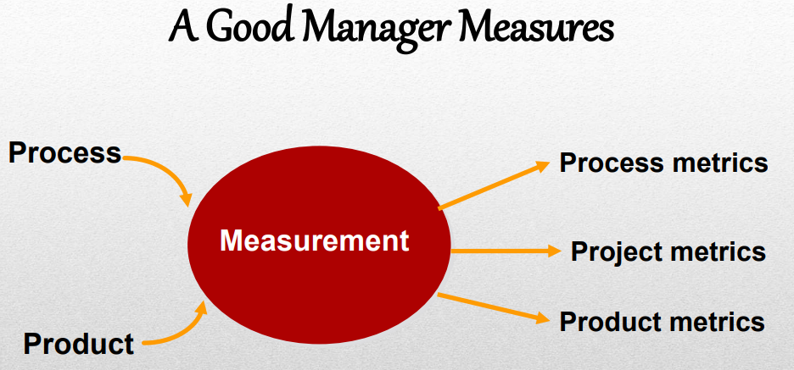
Metrics Guidelines
- Don’t use metrics to judge or criticize individual people.
- Work with team members to set clear goals and decide which metrics will be used.
- Never use metrics to scare or threaten people or teams.
- If metrics show a problem, don’t think of it as something bad—it is just a signal to improve.
Rules for Metrics
- Metrics should be easy to understand so they can be useful.
- Metrics should be tested in real situations to make sure they work properly.
- Metrics should be useful at different levels (team level, project level, management level).
Qualities of Good Metric
- Should be easy to understand and easy to measure clearly.
- Should be objective (not based on personal opinion).
- Should be easy and cheap to collect.
- Should be valid (it should measure what it is supposed to measure).
Some Questions
How big is the program?
- Huge!!
How close are you to finishing?
- We are almost there!!
Can you, as a manager, make any useful decisions from such subjective information?
Need information like, cost, effort, size of project.
Size Oriented Metrics
- Based on the “size” of the software produced.
- LOC - Lines of Code
- KLOC - 1000 Lines of Code
- Typical Measures:
Errors/KLOC, Defects/KLOC, Cost/KLOC, Documentation Pages/KLOC
Size Oriented Metrics
Advantages:
- Lines of Code (LOC) are easy to count.
- Many estimation models use LOC/KLOC for planning and cost estimation.
Disadvantages:
- LOC depends on programming language and programmer style.
- It is hard to get accurate details for estimation.
Example:
A program written in Java may have more lines than the same program in Python, so LOC can be misleading.
Types of Test Metrics
- Process Metrics
- Project Metrics
- Product Metrics
Process Metrics
- Process metrics are measurements that show how the software development process is working, such as development time and the method used.
- They are collected from many projects over a long time to find improvements in the process.
- Their main purpose is to help improve the software development process in the future.
Example:
- Tracking how long a project takes from start to finish.
- Checking whether Agile or Waterfall method gives better results over time.
Project Metrics
Project metrics are measurements used to track and control a software project.
They help in reducing delays by managing time, risks, and problems during development.
Example:
- Checking if the project is on schedule.
- Adjusting team work to avoid delays or risks.
Project Metrics
- Metrics are used in estimation and technical work.
- Data from past projects helps estimate time and effort for new projects.
Example:
If a previous project took 2 months, a similar new project can be estimated around 2 months using past metrics.
Product Metrics
Product metrics are measurements of the software product at different stages, from requirements to final system.
They help in checking things like:
- How complex the design is.
- How big the software is.
Example:
- Measuring number of modules shows design complexity.
- Counting lines of code shows size of the program.

Types of Software Measurements
Direct measures
- Easy to collect
- E.g. Cost, Effort, Lines of codes (LOC), Execution Speed, Memory size, Defects etc.
Indirect measures
- More difficult to assess & can be measured indirectly only.
- Quality, Functionality, Complexity, Reliability, Efficiency, Maintainability etc.
Software Process Improvement
- Measure specific parts of the process.
- Convert these measurements into useful metrics.
- Use metrics to get indicators (understanding of performance).
- Use these indicators to make a plan for improvement.
Example:
If testing time is high → create metrics → indicator shows delay → improve by adding more testers or better tools.
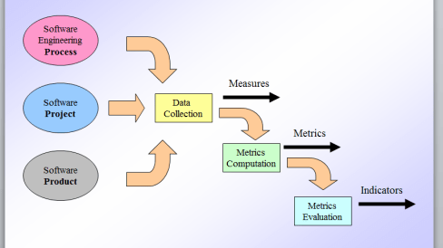

Measurements Examples
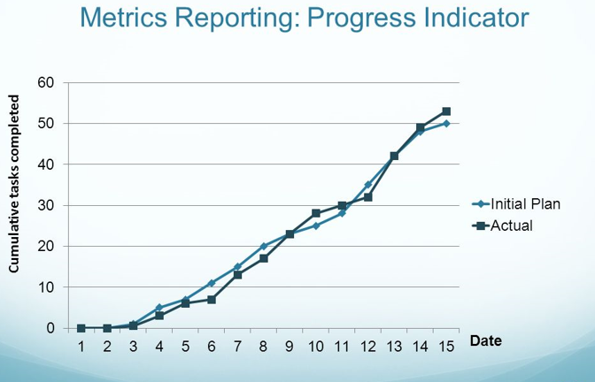
Lecture 12
Software Quality Measurements
What are Measurements?
Measurements mean assigning numbers to things in the real world so we can understand and compare them.
In simple words:
Measurement = turning real-world things into numbers
Example (Real World → Math World)
If:
- A is taller than B
- B is taller than C
Then:
- A is taller than C
This shows that real-world relationships can be represented using logic and numbers.
Software Measurements
In software, we also measure things to understand them better.
Example: Software Size
One common way to measure software size is:
LOC (Lines of Code)
- It means counting how many lines of code a program has
- More lines = bigger software (usually)
Quality that Matters
Company A beats company B, because of which reason do you think?
(1) A deliver more features than B
(2) A has larger market share
(3) A deliver software with fewer bugs
(4) A is cheaper
The correct answer is:
- (3) A delivers software with fewer bugs
Why other options are weaker?
(1) More features
More features don’t help if the software is full of bugs
(2) Larger market share
That shows popularity, not quality
(4) Cheaper
Cheap software with bugs is still bad
Software Quality Matters
Producing high-quality software is very important for a company’s long-term success (like earning profit and growing).
Quality does not happen by chance. It comes from proper planning, good design, careful development, and thorough testing.
Managing Software Quality
Define what quality means
Decide clearly what “good quality” is for the software (like fast, reliable, easy to use).
Measure quality
Check the quality of the whole system or parts of it (for example, count bugs, test performance).
Improve quality
Take steps to make the software better (fix errors, improve design, optimize code).
Process improvement
Make the development process better so future software is higher quality.
Monitor during development
Keep checking quality while building the software, not just at the end.
Some Quality Metrics
- Performance
- Reliability
- Correctness
- Maintainability
- Security
- Interoperability
- Usability
- Extensibility
Performance
- Performance depends a lot on hardware (like CPU, RAM), but we can also improve it using software.
- In many cases, software can be improved by using better algorithms or an optimizing compiler.
- Upgrading hardware is sometimes costly.
- Advice: Find and focus on the slow parts (bottlenecks) in your program and improve them.
Performance Metrics
CPU cycles, in relation to the input size.
How many processing steps (work by the CPU) are needed as the input gets bigger.
Cache misses, in relation to the input size.
How often the CPU cannot find needed data in fast memory (cache) when input size increases.
Network delay.
The time taken for data to travel from sender to receiver.
Network throughput.
How much data can be successfully transferred over a network in a given time.

Software Complexity
Software code base has increasing complexity.
As software grows, its code becomes more complicated.
As a result, the code is harder to maintain.
Because of this, it becomes difficult to fix bugs, update, or improve the code.
This is the central theme of Software Engineering.
A main goal of software engineering is to manage and reduce this complexity.
Well-understood complexity metrics
There are standard ways to measure how complex a program is.
McCabe cyclomatic complexity
A method used to measure how many different paths or decisions exist in a program, showing how complex the code is.
Complexity Metrics
- Source size or compiled size
- Lines of code (LOC)
- McCabe's complexity
Example of a Control Flow Graph (CFG)
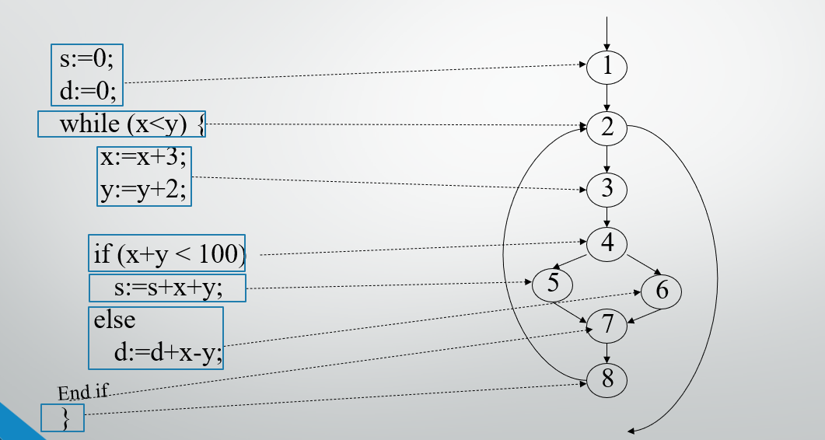
CFG representations for Program Constructs
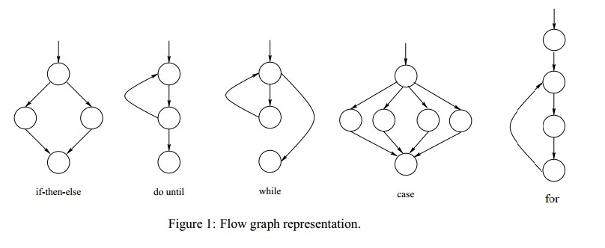
Complexity Example
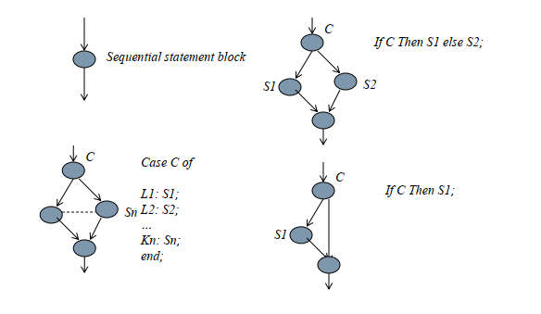
Complexity Example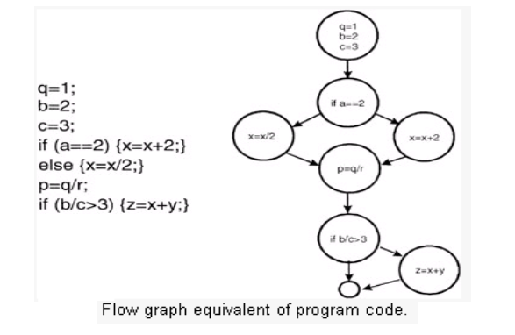Cyclomatic complexity
- Cyclomatic complexity is a software metric (measurement).
- It was developed by Thomas J. McCabe in 1976 and is used to indicate the complexity of a program.
- It directly measures the number of linearly independent paths through a program's source code.

Cyclomatic complexity
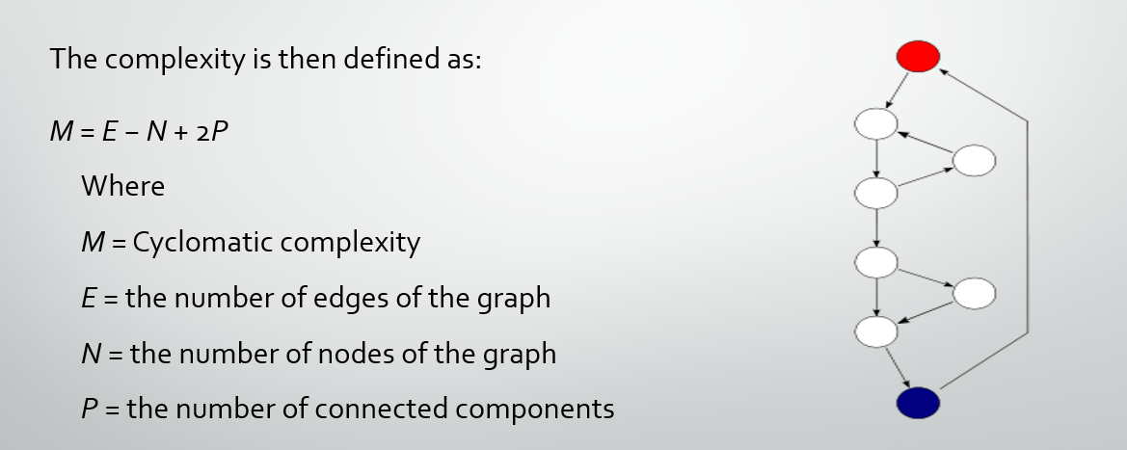
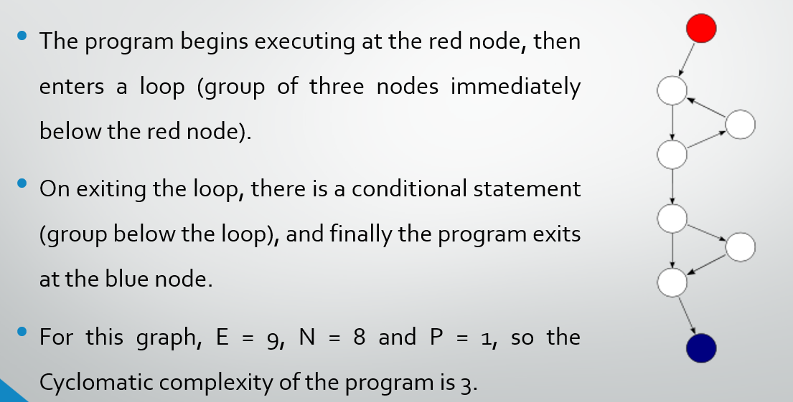
Correlation to Number of Defects
Many studies have looked at how cyclomatic complexity is related to the number of defects (bugs) in a module.
Most studies show a strong positive relationship: modules with higher complexity usually have more defects.

Problems Identified
- To calculate LOC, you have to wait until the system is implemented.
- This is not adequate when management requires prediction of cost and effort.
Lecture 13
Software Measurements Goals
Software Measurement Goals
A measurement is useful only if it helps us understand the process or the final product.
Organizations set goals and use measurements to help achieve those goals.
Software Measurement Goals
Improvement is possible only when the project has clear goals for the process and the product.
Clear goals help in choosing the right measurements (metrics) for the project.
Goal–Question–Metric (GQM) Paradigm
GQM is a method used to create a system for measuring and improving things in a project or organization.
Steps:
- Set goals
First, decide what you want to achieve or improve in the organization.
- Ask questions
Then, make questions that help you understand whether you are reaching those goals.
- Find metrics (measurements)
Finally, choose numbers or data (metrics) that can answer those questions and show progress toward the goals.
Goal–Question–Metric (GQM) Paradigm
List goals
First, write down the main goals of the development or maintenance project.
Make questions
Then, create questions from each goal that help you check whether the goals are being achieved or not.
- Example: If the goal is "Reliability," a question might be "What is the average time between system failures?"
Choose metrics (measurements)
Finally, decide what data or measurements are needed to answer those questions properly.
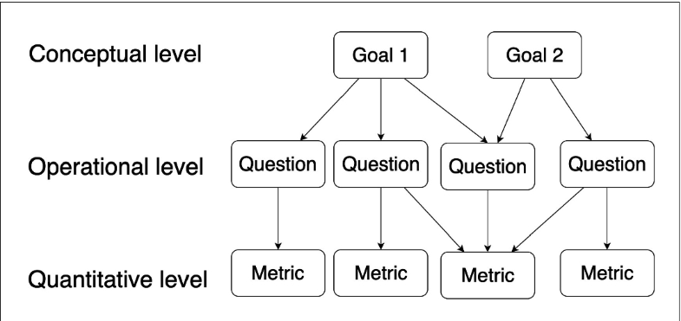

1. Conceptual Level (Goal Level)
- This is the big idea / intention
- Focus: What do we want to achieve?
- It is abstract (not measurable directly)
Example:
- Improve software quality
- Increase customer satisfaction
2. Operational Level (Question Level)
- This turns the goal into practical questions
- Focus: How do we check if the goal is achieved?
- Makes the goal clear and testable
Example (from "Improve software quality"):
- How many bugs are found after release?
- Are users facing frequent crashes?
- How often does the system fail?
These are questions, still no actual data yet.
3. Quantitative Level (Metric Level)
- This is the measurement part (numbers/data)
- Focus: What data do we collect to answer questions?
- Fully measurable
Example:
- Number of bugs per release
- Crash rate (%)
- Number of system failures per week
- Average bug fixing time (hours)
These are exact values (numbers).
Goal–Question–Metric (GQM) Paradigm
- First, we write the main goals of the organization.
- Then, we make questions that help us check whether those goals are being achieved or not.
- After that, we decide what data or measurements are needed to answer each question properly.
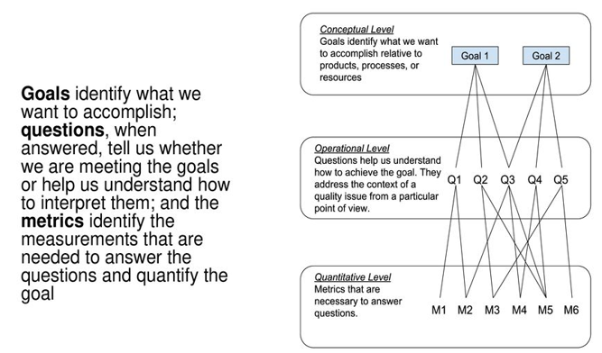
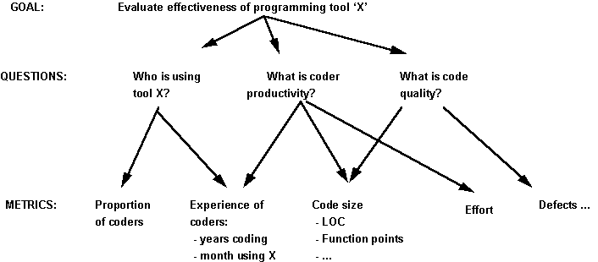
Goal–Question–Metric (GQM) Paradigm
- Goals are written in terms of things like productivity, quality, risk, and customer satisfaction.
- Goals and questions should be made according to the needs of the people who will use them (the audience).
Example of GQM
Goal:
Improve customer satisfaction in a mobile banking app.
Questions:
- How many users are satisfied with the app?
- How often do users face problems while using the app?
- How quickly are user complaints solved?

Metrics (measurements):
- Customer satisfaction score (from surveys)
- Number of app complaints or error reports
- Average time taken to solve customer issues
Data Requirements
- Software metrics are ways of measuring different activities in software development. These activities involve some form of measurement.
- The success of software measurement depends on how good the collected and analyzed data is.
What is Good Data?
The data collected can be considered as a good data, if it can produce the answers for the following questions
1. Are they correct?
A data is correct, if it was collected according to the exact rules of the definition of the metric.
Example:
- Metric: Number of students present in class
- Correct data: You count only students who are physically present in the classroom.
- Incorrect data: You also include absent students or those on leave.
2. Are they accurate?
Accuracy refers to the difference between the data and the actual value.
Example:
- Metric: Student height
- Actual height: 170 cm
- Measured value: 169 cm or 171 cm → Accurate
- Measured value: 160 cm → Not accurate
3. Are they consistent?
Data can be considered as consistent, if it doesn’t show a major difference from one measuring device to another.
Example:
- Metric: Student height
- Measured with tool 1 → 170 cm
- Measured with tool 2 → 171 cm → Consistent (very small difference)
- Measured with tool 1 → 170 cm
- Measured with tool 2 → 185 cm → Not consistent
4. Are they associated with a particular activity or time period? −
If the data is related to a specific activity or a specific time period, then it must be clearly mentioned with the data.
Example:
- “Number of bugs found during testing phase (March 2026) = 25”
This is good data because it clearly shows activity (testing) and time period (March 2026).
- “Number of bugs = 25”
This is not good data because we don’t know when or during which activity it was collected.

How to Define Data
- Raw data − Raw data is the first collected data from measuring processes, products, or resources.
For example: Weekly timesheet of employees in an organization.
- Refined data − Refined data is the useful data taken from raw data after processing it to get important values.
For example: Number of employees present and absent in an organization.
How to Collect Data
- Collecting data needs human observation and reporting.
- Managers, system analysts, programmers, testers, and users record raw data using forms or reports.
How to Collect Data
- Keep procedures simple.
- Avoid unnecessary recording.
- Train employees.
Lecture 14
Project & Process Metrics
What is Project Management Metrics?
Project management metrics are measurements used to check how well a project is going. They help us track progress, performance, cost, time, and quality of a project.
Why use Project Management Metrics?
Project management metrics help us understand the project better by reducing confusion and uncertainty, so we can make better and smarter decisions.
Cost-related project management metrics show a team’s value by measuring how efficiently they complete work within the given budget.
How do you choose metrics?
- Understand the main goal or purpose of the project.
- Identify the key factors that are important for success.
- Decide how you will measure each of those success factors.
Project Management Metrics
1. Productivity
- Productivity shows the relationship between input and output.
- It means how much result you get from the effort and resources you put into a project.
- The ideal productivity is to produce more using fewer resources.
- Productivity = Units of Input / Units of Output
2. Gross Profit Margin
Any work or activity done in a business should help it earn profit.
Gross Profit Margin shows how much profit is left after removing the direct cost of making or buying products. It is shown in percentage.
It tells us:
How much money is left from every 1 dollar (or rupee) of sales after covering basic costs.
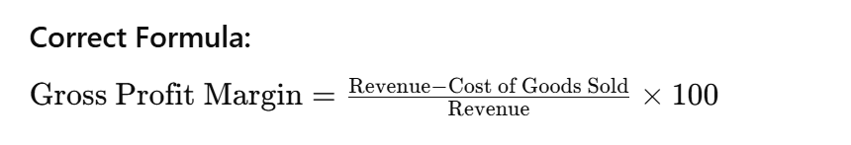
3. Return on Investment (ROI)
Return on Investment shows how much profit or benefit a business gets from the money it spends on a project or work.
It tells us:
“How much return (profit or savings) we get compared to what we invested.”
Correct Formula:
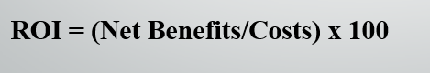
Easy Meaning of Terms:
- Net Benefits = total benefits earned (profit, savings, etc.)
- Costs = total money spent on the project
- ROI = percentage of return from investment
Simple Example:
If you invest 1000 and gain 1200 total benefit:
- Net Benefit = 1200 − 1000 = 200
- ROI = (200 ÷ 1000) × 100 = 20%
In simple words:
ROI tells us how much profit or benefit we got from the money we invested in a project.
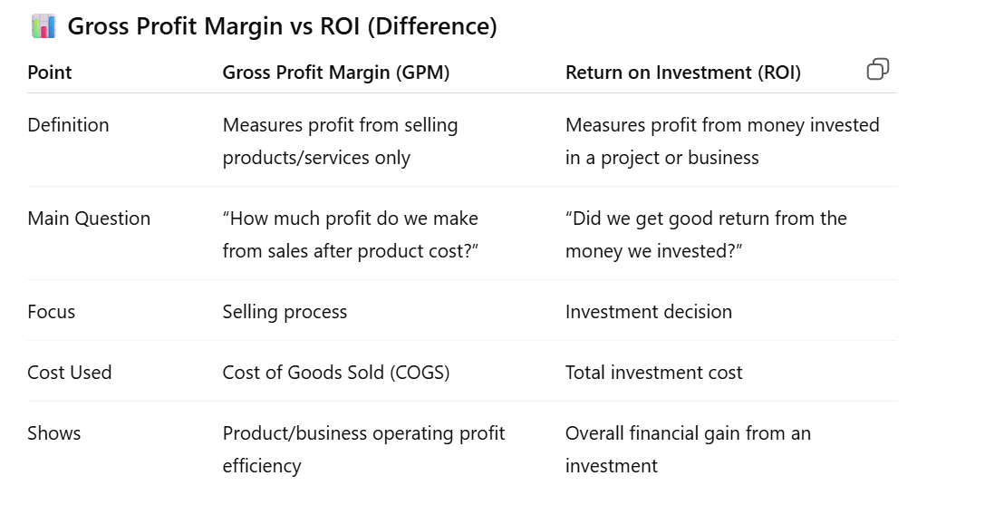
4. Customer Satisfaction
Customer Satisfaction shows how happy customers are with a product or service.
It is measured using survey questions where customers give scores.
These scores help a company understand the quality of its service or product.
Each company can decide its own scoring method by giving more importance to some questions than others.
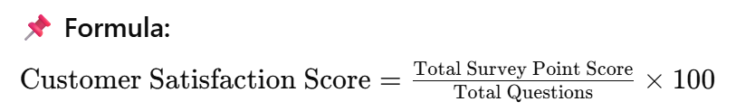
Simple Example:
If customers give total 80 points for 10 questions:
- Score = (80 ÷ 10) × 100 = 80%

5. Employee Satisfaction Score
Employee Satisfaction shows how happy employees are with their job, workplace, and environment.
It is measured using survey questions where employees give scores.
Happy employees usually work better and more efficiently.
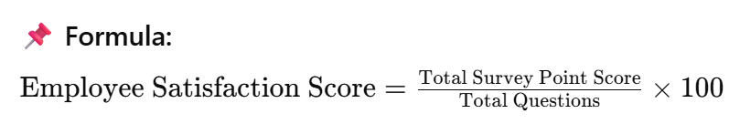
Simple Example:
If employees give total 90 points for 10 questions:
- Score = (90 ÷ 10) × 100 = 90%
Software Process Metrics
They are used to improve how software is developed.
The purpose is to give useful indicators that help make better decisions and improve the process over time.
Human effort spent
These measures how much time and work (hours/days) developers spend on a project.
Conformance to the schedule
This checks whether the project is being completed on time according to the planned schedule.
Software Process Metrics
Defect Density
It shows how many errors (defects) are found in the software compared to its size.
It is calculated by dividing total defects by the size of the software (usually in KLOC – thousand lines of code).
Defect Removal Efficiency (DRE)
It shows how effectively defects are found and fixed before the software is delivered to the customer.
Ishikawa Fish-Bone Diagram
The data collected from process metrics is used to create the fishbone diagram.
A completed fishbone diagram is then analyzed to find the main causes of problems.
These causes help a software organization improve its process and reduce errors and defects.
In easy wording
- First, collect data (metrics)
- Then, use the fishbone diagram to find causes
- Finally, improve the process to reduce mistakes
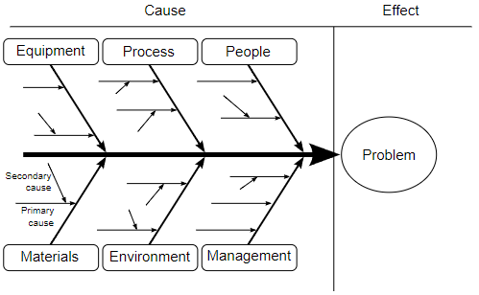
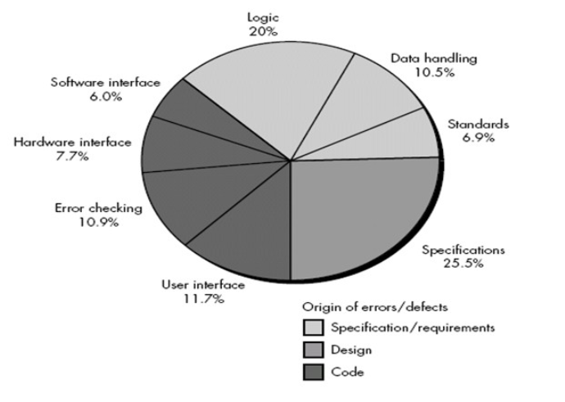
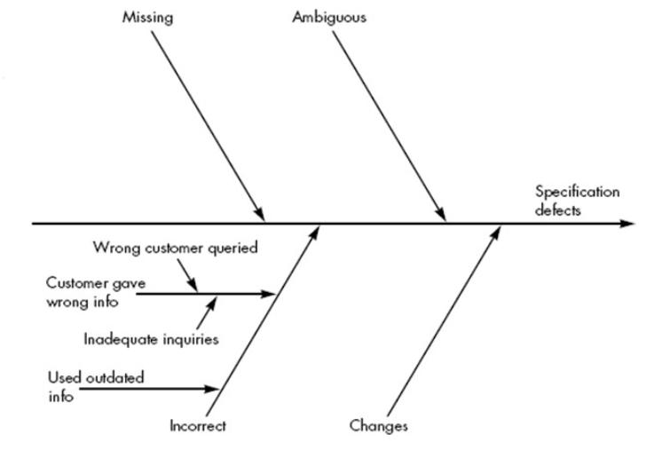

Fish-Bone Diagram
- For the pie-chart noted in the figure, eight causes of defects and their origin.
- The spine of the diagram (the central line) represents the quality factor under consideration (in this case specification defects).
- Each of the ribs (diagonal lines) connecting to the spine indicate potential causes for the quality problem (e.g., missing requirements, ambiguous specification).
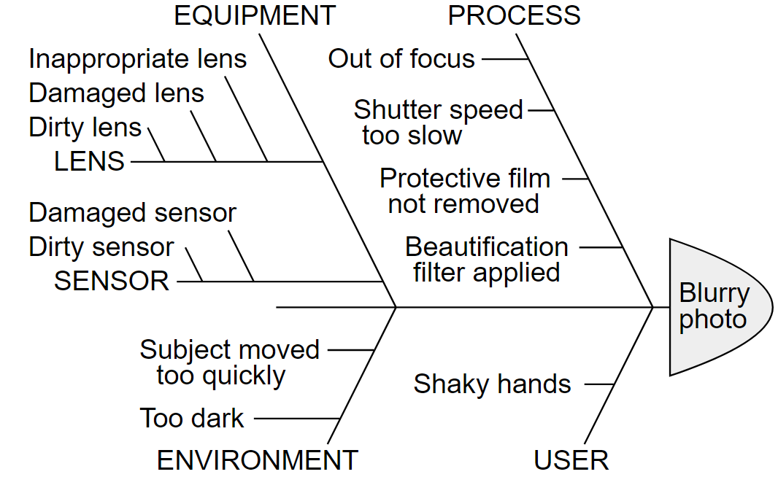
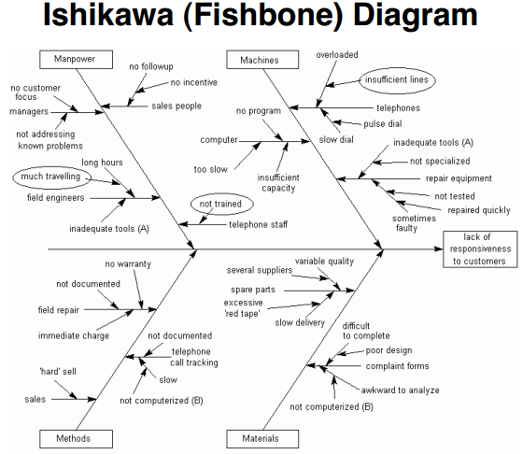
Important Questions
- What is Product, Process and Project Metrices? Explain Differences Between them?
- You are given with any problem and were asked to identify then causes of that problem and then draw a fish bone diagram using those causes?
Lecture 15
Product Based Metrics
Product Metrics
These metrics measure the software product itself (the final system or application).
What it means
They tell us about the quality and size of the software.
Examples
- Number of bugs in the software
- Code size (KLOC – thousand lines of code)
- Performance (speed of software)
- Reliability (how often it fails)
Product Based Metrics
Product metrics can be different for different types of software products and industries.
Every product does not use the same measurements.
However, there is a common set of useful metrics that can be used for almost all software products.
Choosing the right metrics (Key Performance Indicators - KPIs) is very important in product development because they help to measure success and quality.
Functional Point Analysis
- Instead of measuring size, function points measure the functionality offered by a system.
- Invented by Albrecht at IBM in 1979, still in use today.
- A Function can be defined as a collection of executable statements that performs a certain task.
- Function points can be calculated before a system is developed.
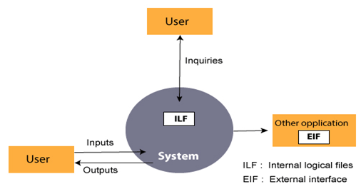
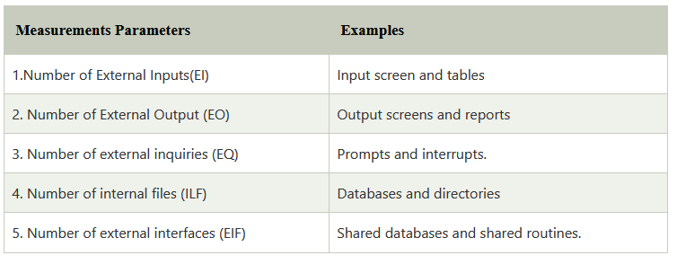
Function Points
Transaction Functions
- External Inputs
- External Outputs
- External Inquiries
Data Functions
- Internal Logic Files
- External Interface Files
Transaction Functions
External Inputs:
External Input (EI) is a transaction function in which data goes “into” the application from outside the system boundary. This data comes from outside the application. Data may come from a user input screen or another application.
External Outputs:
External Output (EO) is a transaction function in which data goes “out of” the system. The system processes the data and produces results like reports or output files that are sent to users or other applications.
External Inquiries:
External Inquiry (EQ) is a transaction function where the system both takes input and gives output to only show data. It is used to fetch data from files and display it to the user without changing it. No extra processing is done.
Data Functions
Internal Logic Files (ILF):
Internal Logical File (ILF) is a group of related data or information that is inside the system boundary. This data is stored and maintained within the application itself. It has a logical structure and is kept in a file or database.
Example: Employee file stored inside a company system.
External Interface Files (EIF):
External Interface File (EIF) is a group of data that the system uses from another system but does not maintain or update itself. It is used for sharing or exchanging data between different systems.
EIF can include business data, control data, or rules-based data.
Example: Customer information like names, addresses, and phone numbers stored in another system but accessed by your application.
Function Points (FPs)
Function Points (FPs) of a software application are calculated by counting the number and types of functions used in the system.
FP helps to measure how large and complex a software system is.
It is also used to estimate:
- Project time
- Manpower (number of people needed)
UFP (Unadjusted Function Point)
The functional complexities are multiplied with the corresponding weights against each function, and the values are added up to determine the Unadjusted Function Point (UFP) or count total of the subsystem.
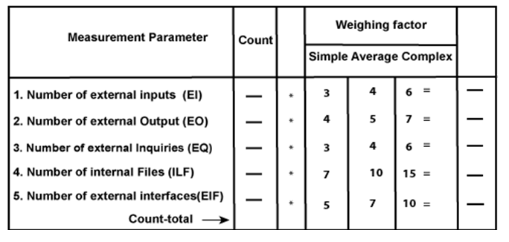
Function Point Analysis Steps
- Determine the components (EI, EO, EQ, EIF, ILF).
- Compute the Unadjusted Function Points (UFP) or count total.
- Compute Value Adjustment Factor (VAF) based on 14 general system characteristics (GSC).
- Calculate the final function point.

Function Points
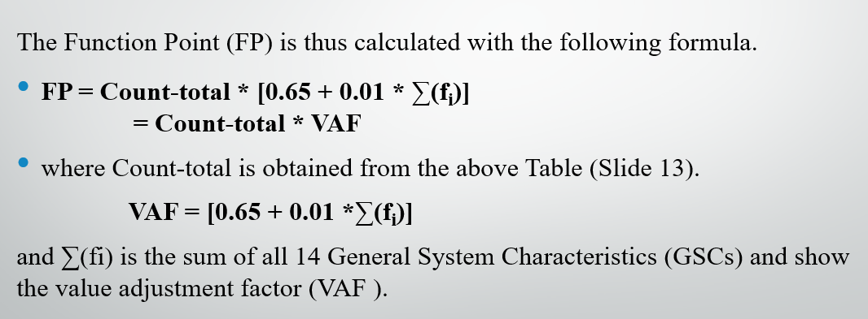
General System Characteristics (GSCs)
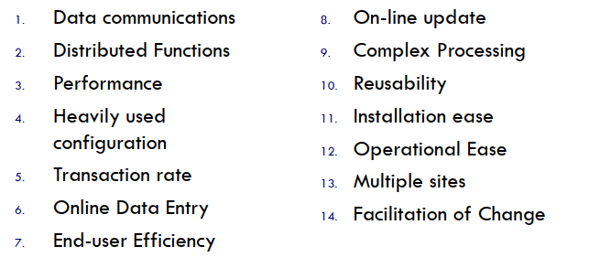
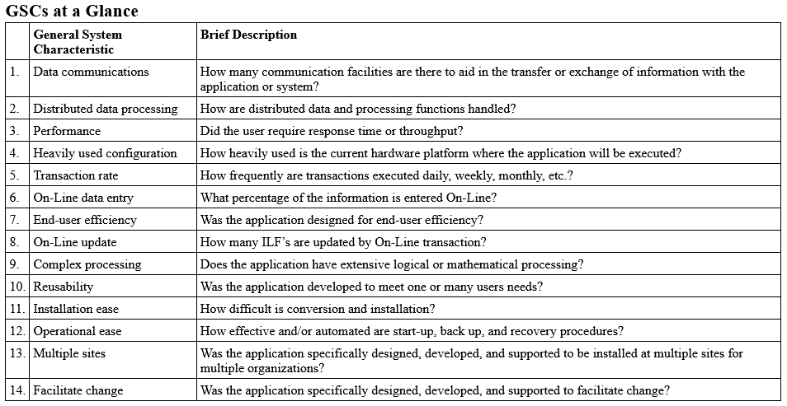
General System Characteristics (GSCs)
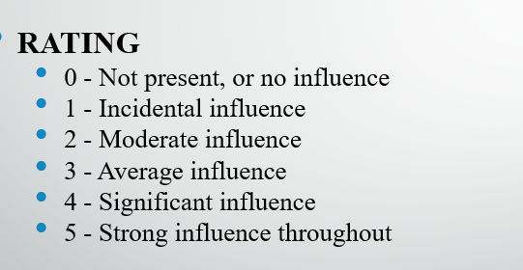
Value Adjustment Factor (VAF)
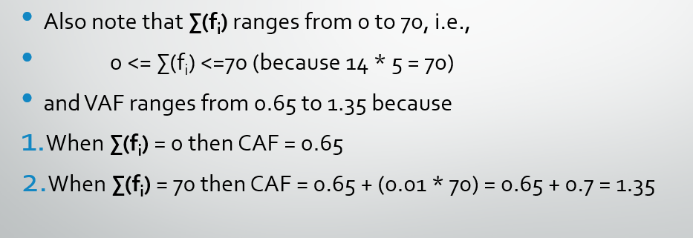
Example
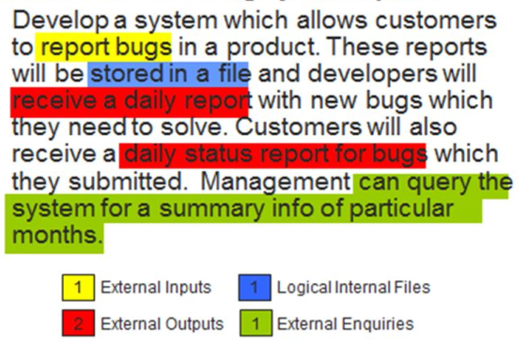

Function Points
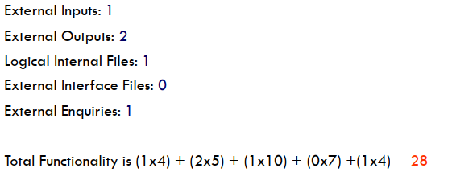
GSC Calculation
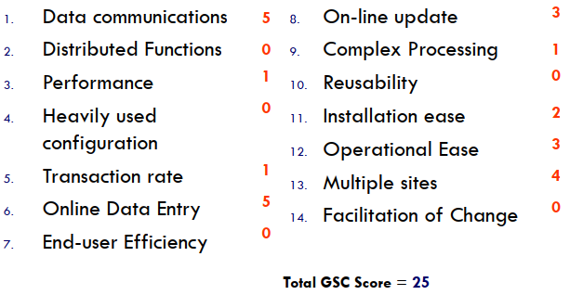
Result
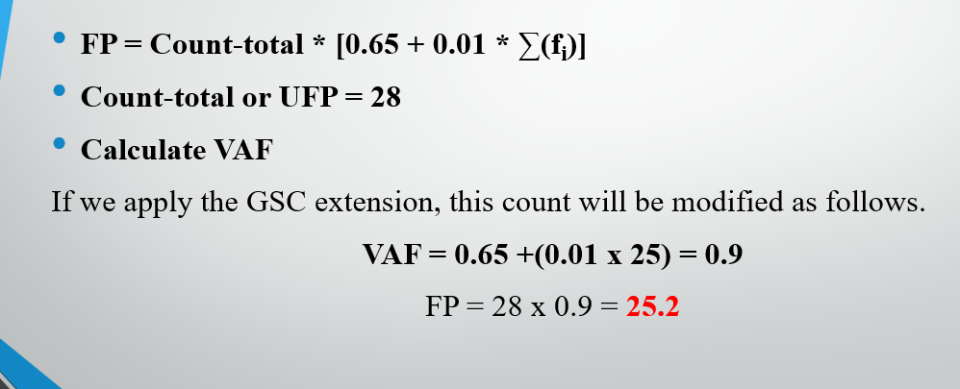
Function Points (FPs)
Based on the FP measure of software many other metrics can be computed:
- Errors/FP
- $/FP
- Defects/FP
- Pages of documentation/FP
- Errors/PM (person-months)
- Productivity = FP/PM (effort is measured in person-months).
- $/Page of Documentation
Function Points (FPs)
- LOCs of an application can be estimated from FPs. That is, they are interconvertible. This process is known as backfiring.
- For example, 1 FP is equal to about 100 lines of C code.
- FP metrics is used mostly for measuring the size of Management Information System (MIS) software.
FP & Loc
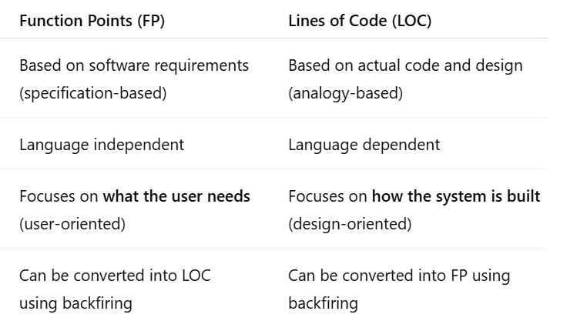
Lecture 16
Quality Improvement Models
Definition
A Quality Model is a group of important features of a software and how they are related. It helps us define what quality is needed and also check how good the software is.
Why Quality Models?
- General definitions of quality are not enough.
- Software quality must be described using quality models.
- They help connect unclear (intangible) quality ideas to clear (tangible) software measurements.
The Role of Quality Models
Quality models are made to help important quality assurance activities.
- Quality Requirements Definition
It helps to clearly define what quality is needed in a software or system.
- Constructive Quality Assurance
It helps in building the product in a way that good quality is achieved from the start.
- Analytic Quality Assurance
It helps in checking and evaluating the product to find defects and improve quality.

Introduction
Analytical models give numbers to measure software quality features.
When we use them again and again over time, they help us predict future quality more accurately.
Purpose of Measurement and Analysis
- Make corrective actions → improve the system.
- Provide quick feedback → understand current performance.
- Find problem areas → where issues are happening.
- Prediction → plan schedule and resources in advance.
Models for Quality Improvement
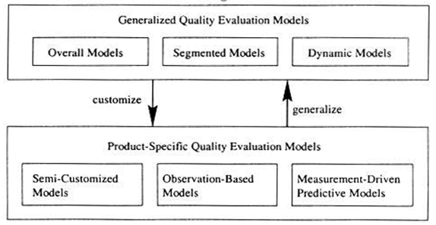
Generalized Models for Quality Improvement
These models do not need much project-specific data. They give a general idea about quality.

Three types:
Overall model – gives one simple overall score of product quality.
Example: A software is rated as “good quality” based on total testing results.
Segmented model – gives different quality results for different groups or industries.
Example: A system may have high quality for banking use but medium quality for education use.
Dynamic model – shows how quality changes with time or during development. It is used for larger Project.
Example: Software quality improves after each testing and update step.
Overall Models
These models give a rough (general) idea of product quality.
Example formula:
Defect Density = Total Defects / Product Size
(It shows how many defects are found in a given size of software.)
They combine all products and give a general rule about quality that works in most systems.
Example:
80:20 rule → 80% of defects come from only 20% of modules/components.
They also show relationships between defects, risks, and process maturity to understand software quality.
High process maturity → fewer defects → lower risk → better software quality

Segmented Models
These models describe quality based on different types of product markets (segments).
They show that different kinds of software need different levels of quality.
Reliability levels (measured by failure rate):
- Safety-critical software → very high reliability needed
Example: medical devices, nuclear reactors (even a small error is dangerous)
- Commercial software → medium to high reliability
Example: telecom systems, banking and business software (must work properly but small errors may be acceptable)
- Auxiliary software → lower reliability needed
Example: games, low-cost PC software (small bugs are less serious)
Example of Segmented Model
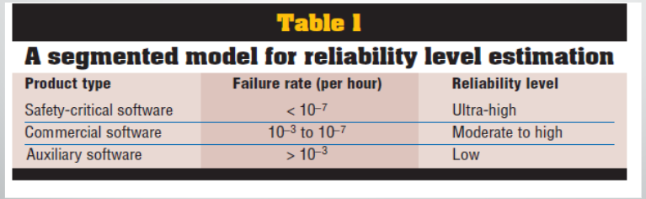
Dynamic Models
These models show how software quality changes over time or during different development phases.
They help us understand quality step by step.
Examples:
- Defect distribution profile → shows how bugs are spread across different development stages (like design, coding, testing).
- Reliability growth → shows how software becomes more reliable during testing as defects are found and fixed.
They can also be combined with segmented models to form segmented dynamic models, which show quality changes over time for different types of software.
Example of Dynamic Model
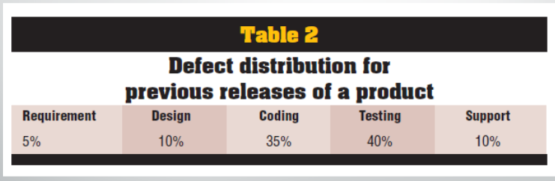
Product-Specific Models
Provide more precise quality assessment using product-related data.
Three categories:
- Semi-customized models – Use past project history to predict quality of the current project. It is general because it uses information that is not specially created for the current project. It takes data from past projects. Then it is later adjusted for the current project, which is why it becomes semi-customized. So, it is general because the starting point is old, reused project history.
- Observation-based models – Estimate quality by observing the current project during development.
- Measurement-driven predictive models – Use early measurements to predict the final quality of the software.
Semi-Customized Models
Use past project information and general data about product, process, or environment, and adjust it for the current project.
Example:
Defect Removal Models (DRMs) show how defects were distributed and removed in previous versions of the same product, and use this information to predict defects in the current project.
Observation-based Models
These models do NOT rely on past history only.
Instead, they observe what is happening in the current project and use that real data to judge quality.
In simple words:
We watch the software while it is being developed or tested, and use that information to measure quality.
How it works
The software is being developed or tested.
We collect real-time data (observations) like:
- number of bugs found
- testing results
- failures
- performance issues
We analyze this data
We estimate quality (like reliability, defect rate, etc.)
Simple Example
Imagine you are testing a mobile app:
- You find 20 bugs in 1st week
- You find 10 bugs in 2nd week
- You see bugs are decreasing
Now you can estimate:
“The software quality is improving over time”
OR
“We can predict how many bugs might remain”
Measurement-driven predictive models
These models use old project data to find simple connections between measurements (like defects, size, etc.) and software quality.
- Provide early predictions of quality.
They guess the software quality early, even before the project is fully done.
- Identify problems early for timely actions.
They help find possible problems early so they can be fixed quickly.
- Use statistical analysis techniques / learning algorithms.
They use math methods and computer learning to make predictions.

Lecture 17
Model Comparison
Model Comparison and Interconnections
Comparisons based on:
- How useful the model results are
- How accurate the quality predictions are
- Whether the model can work in different environments
Model inter-connections can be examined:
- How much we need to modify a general model to make it fit a specific product
- How general quality models are turned into product-specific models
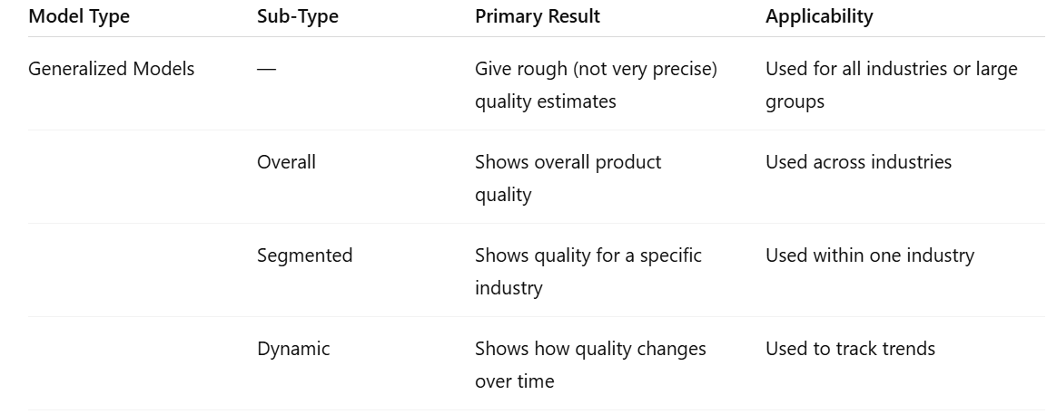
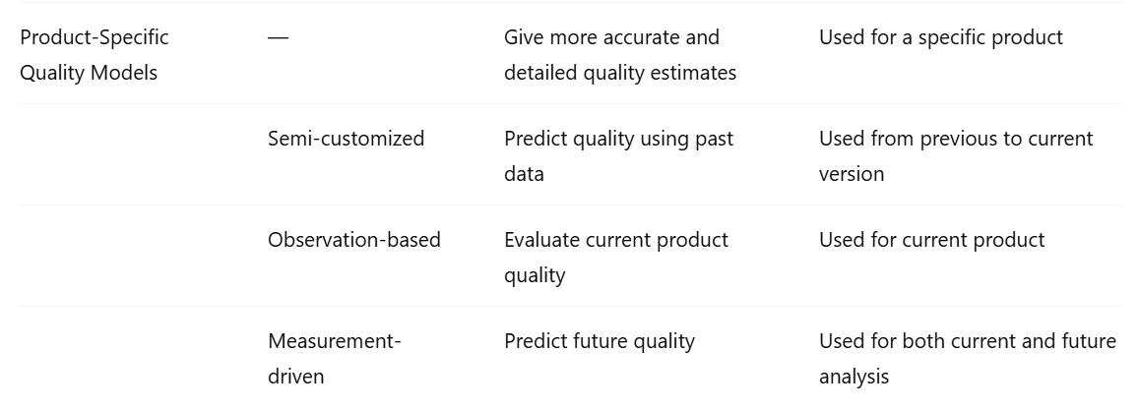
Comparisons
Usefulness should be compared with cost (like the effort of collecting data).
Why generalized models are cheaper:
Generalized models can be used in many places and are cheaper because they use general rules and common data, so you don’t need to collect detailed data for a specific product → saves time and cost.
Why they are useful in early stages:
At the beginning (planning/development), product data is not available yet → so generalized models help give an initial idea of quality.
Why semi-customized models are better when data exists:
If you already have past data, these models use it → giving more accurate and reliable results.
Comparisons
1. Better Management of QA Activities:
- Observation-based and measurement-based models help manage QA, development, and maintenance better.
- This is because more data is collected over time, making decisions more accurate.
2. Dependence on Data and Analysis:
- Their effectiveness depends on the type of data collected.
- It also depends on how well the data is analyzed.

Comparisons
1. Relationship Between Models:
- Generalized models and product-specific models are related to each other (they have similar versions).
2. Customization:
- Generalized models can be modified (customized) to create product-specific models.
3. Generalization:
- Product-specific models can also be turned into generalized models for wider use.
Data Requirements and Measurement
Data Requirements and Measurement
Different models need different types of data (direct or indirect).
Generalized Models
- These models use average data taken from the industry or from a group of similar products.
- They do not need data from the current project.
- But the data collected from the current project can be saved. This saved data helps improve the model for future projects.

Product-Specific Models
1. Measurement-driven models
- These models are based on real measurements from a specific product.
- They use both direct and indirect quality data (from process, product, and people).
- They also need early data from past or current versions of the product.
2. Semi-customized models
- These models are partly adjusted for the current project.
- They use information about the environment (like team, process, tools) to understand the project.
- They also use results from past versions of the software to estimate quality.
3. Observation-based models
- These models use direct data from the software (like bugs, errors, speed).
- They assume the working environment stays the same while measuring quality.
Direct and indirect Data
1. Direct data = “What is inside the product?”
This is data you can measure directly from the software itself.
Example:
- How many bugs are in the system
- How fast the system runs
- How many lines of code are written
This shows what is happening in the product right now
2. Indirect data = “What affected the product?”
This is data about things that influence the product, but are not the product itself.
It comes from:
- Process → How the software was built (testing, development method)
- People → Developer skill or experience
- Product history → Past versions and changes
This is like checking the reasons behind the product’s quality
Summary of Data Requirements
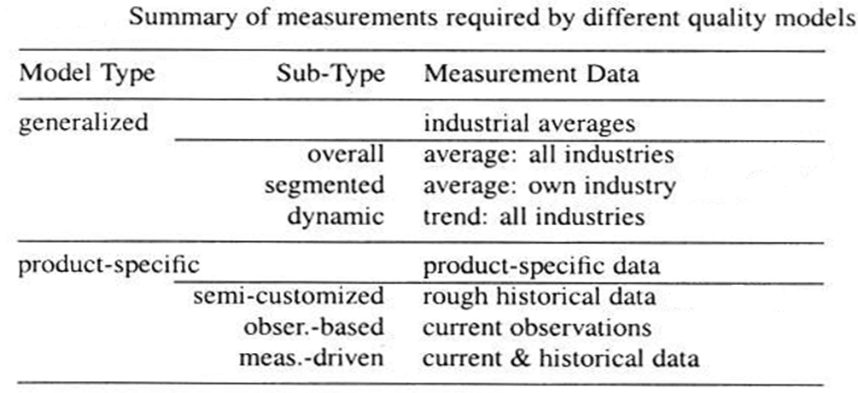
Models Supported by Kind of Data
Direct quality measurements
Used in all product-specific models.
They measure the software directly (like bugs, performance, errors).

Product-specific extrapolations
Used in semi-customized models.
They estimate current quality using results from past or previous versions of the same product.
Development activities
Used in observation-based models.
They look at how the software is being developed (like process, testing, team work) to judge quality.
Selecting Measurements and Models
Goal-oriented approach (GQM)
We first use a clear method called GQM (Goal–Question–Metric).
It helps us decide what we want to achieve.
Set specific quality goals
We define clear goals like “the software should be very reliable” or “it should have fewer errors.”
Choose suitable quality models
We select models that can help answer our quality questions and meet our goals.
Choose proper measurements
We pick the right data to measure, such as:
- number of failures
- test execution time

Lecture 18
Risk Management
Project Risks
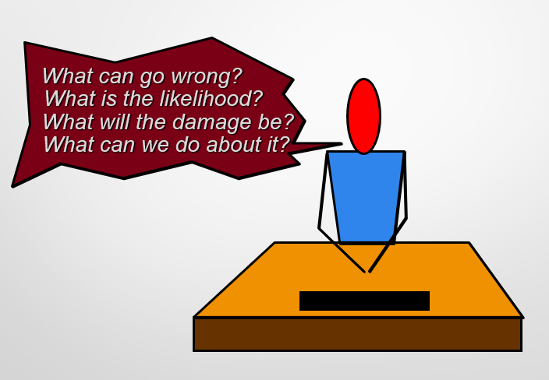
What is Software Risk?
Software risk means a possible problem or loss that may happen in the future during software development.
It may happen or may not happen, but there is always a chance of it occurring.
Causes of Software Risk
Software risk usually happens because of:
- Lack of information: When developers do not have complete or correct information about the project, mistakes can happen.
- Lack of control: When the project is not managed properly, risks increase.
- Lack of time: When there is very little time to complete the project, developers may rush their work.
Definition of Software Risk
The possibility of facing loss during the software development process is called software risk.
Types of Loss in Software Risk
Software risk can cause different kinds of losses, such as:
- Increase in production cost
- Development of low-quality software
- Delay in completing the project on time
Types of Software Risks
Software risk exists because the future is uncertain.
There are many known and unknown factors that cannot be fully included in the project plan.
A Software Risk Can Be of Two Types
1. Internal Risks
Internal risks are the risks that are within the control of the project manager.
Example:
- Poor planning
- Lack of communication in the team
- Shortage of resources
- Delay by developers
These problems can usually be managed or reduced by the project manager.
2. External Risks
External risks are the risks that are beyond the control of the project manager.
Example:
- Changes in market conditions
- New government rules
- Natural disasters
- Internet or power failures
These problems cannot be controlled directly by the project manager.
Risk Categorization
Project Risks
They threaten the project plan.
If these risks become real:
- The project may be delayed.
- Project cost may increase.
Example:
- Lack of staff
- Poor planning
- Delay in resources

Technical Risks
They threaten the quality and timely development of the software.
If these risks become real:
- Developing the software may become difficult or impossible.
Example:
- Use of new technology
- Technical errors
- Integration problems
Business Risks
They threaten the success and usefulness of the software being developed.
If these risks become real:
- The project or product may fail.
Example:
- Loss of customers
- Market changes
- Low profit from the software
Known Risks
Those risks that can be identified after carefully studying:
- The project plan
- Business environment
- Technical environment
- Other reliable information sources

Example:
- Unrealistic delivery date
Predictable Risks
Those risks that can be predicted from past project experience.
Example:
- Employee turnover in previous projects
- Delays that happened in earlier projects
Unpredictable Risks
Those risks that may occur but are very difficult to identify before they happen.
Example:
- Sudden natural disaster
- Unexpected system failure
- Sudden market changes
Risk Management
Risk management is the process of handling risks in a project to reduce problems and losses.
Risk Management is Carried Out To:
1. Identify the Risk
Find and recognize possible risks before they become serious problems.
Example:
- Finding possible delays in the project

2. Reduce the Impact of Risk
Try to decrease the damage caused if the risk happens.
Example:
- Keeping backup resources to reduce loss
3. Reduce the Probability or Likelihood of Risk
Take steps to lower the chances of the risk happening.
Example:
- Proper planning and testing
4. Risk Monitoring
Continuously check and track risks during the project.
Example:
- Regularly reviewing project progress and issues

Reactive vs. Proactive Risk Strategies
Reactive Risk Strategies
Reactive risk strategy means dealing with risks only after a problem happens.
Main Idea
“Don’t worry, I’ll think of something.”
This means the team does not plan for risks in advance and reacts only when trouble occurs.
In Software Teams
Most software teams and managers use this approach.
They do not take action until something goes wrong.
What Happens Then?
When a problem occurs:
- The team quickly starts fixing the issue.
- They try to control the problem rapidly.
This situation is called firefighting because the team rushes to solve the problem suddenly.
Proactive Risk Strategies
Proactive risk strategy means planning for risks before they happen.
Main Objective
The main goal is:
- To avoid risks as much as possible
- To prepare a backup plan for unavoidable risks
Contingency Plan
A contingency plan is a prepared plan to handle problems in a controlled and effective way if a risk occurs.

Example:
- Keeping extra time for possible delays
- Having backup team members or resources
Benefit
This strategy helps:
- Reduce project problems
- Handle risks more effectively
- Keep the project under control
Steps for Risk Management
- Identify possible risks: find out what things can go wrong in the project or situation.
- Analyze each risk: check how likely each risk is to happen (probability) and how much damage it can cause if it happens (impact).
- Rank the risks: arrange the risks according to their probability and impact. Impact can be negligible, marginal, critical, or catastrophic.
- Develop a contingency plan: make a backup plan to handle those risks that have high probability and high impact.
Risk Identification
Risk identification means carefully finding and listing all possible problems or dangers that can affect the project plan.
By identifying risks that are already known or can be predicted, the project manager can take the first step to avoid them if possible, or control them properly if they cannot be avoided.

Risk Identification
Generic risks
These are risks that can affect almost every software project. They are common problems that may happen in any project.
Product-specific risks
These are risks that are related only to a particular software project. They can be identified only by understanding the technology, the team, and the working environment of that specific project.
To find these risks, we carefully study the project plan and the scope statement. We ask questions like:
“What special features or conditions of this product can create problems for our project plan?”
Known and Predictable Risk Categories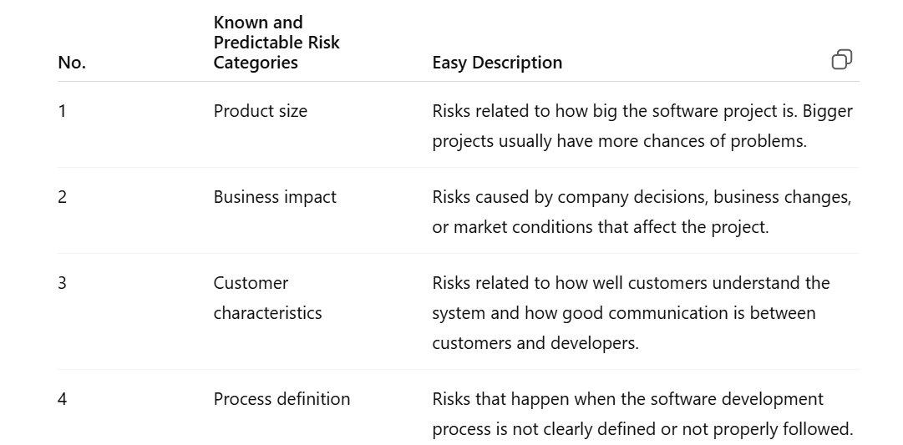
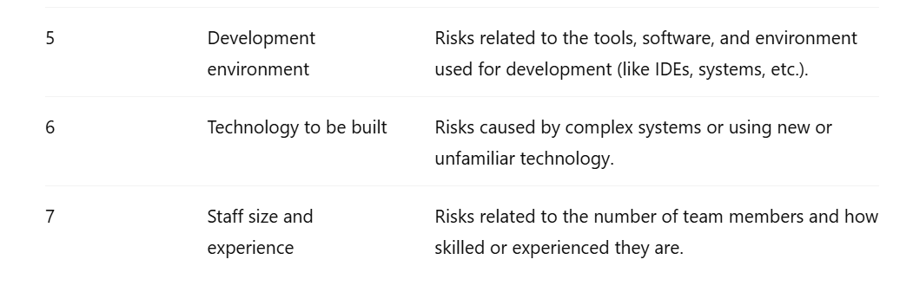
Questionnaire on Project Risk
- Have top software and customer managers clearly agreed to support the project?
- Are the end-users fully interested and committed to the project and the system/product being developed?
- Does the software team and customers clearly understand all the requirements?
- Have customers been fully involved in defining the requirements?
- Do end-users have realistic and practical expectations from the system?
- Is the project scope fixed and not changing frequently?
- Does the software team have the right mix of skills needed for the project?
- Are the project requirements stable and not changing frequently?
- Does the project team have experience with the technology that will be used in the system?
- Is the number of team members enough to complete the project properly?
- Do all customers and users agree on the importance of the project and the requirements of the system/product to be built?
Lecture 19
Risk Management (2)
Risk Components and Drivers
The project manager identifies the risk factors that can affect the following risk components:
Performance risk – the chance that the software may not meet requirements or may not work properly for its intended purpose.
Cost risk – the chance that the project may go over the planned budget.
Support risk – the chance that the software may become difficult to fix, update, improve, or maintain in the future.
Schedule risk – the chance that the project may not finish on time and delivery may be delayed.
Risk Components and Drivers
The effect of each risk factor on a risk component is divided into four impact levels:
- Negligible – very small effect
- Marginal – small effect
- Critical – serious effect
- Catastrophic – extremely serious effect
Risk factors can also be judged by how likely they are to happen:
- Impossible – cannot happen
- Improbable – unlikely to happen
- Probable – likely to happen
- Frequent – happens often
Background
Risk projection (or estimation) tries to measure each risk in two ways:
- The chance that the risk will actually happen.
- The effect or problems caused if the risk happens.
The project planner, managers, and technical team perform four risk projection steps.
The purpose of these steps is to study risks in a way that helps in setting priorities.
By giving priority to important risks, the software team can use limited resources on the risks that will have the greatest effect.
Risk Projection/Estimation Steps
- Establish a scale that shows how likely a risk is to happen (for example: 1 = low chance, 10 = high chance).
- Clearly describe the consequences or problems that may occur because of the risk.
- Estimate how much impact the risk can have on the project and the software product.
- Mention the overall accuracy of the risk estimation so there is no confusion or misunderstanding later.
Risk Table
A Risk Table gives the project manager a simple way to estimate and manage risks.
It contains five columns:
Risk Summary – a short description of the risk
Risk Category – the type of risk from the seven risk categories
Probability – an estimate of how likely the risk is to happen, based on team discussion and input
Impact – the seriousness of the risk:
(1) catastrophic
(2) critical
(3) marginal
(4) negligible
- RMMM – a reference to a section in the Risk Mitigation, Monitoring, and Management Plan where the risk handling strategy is explained
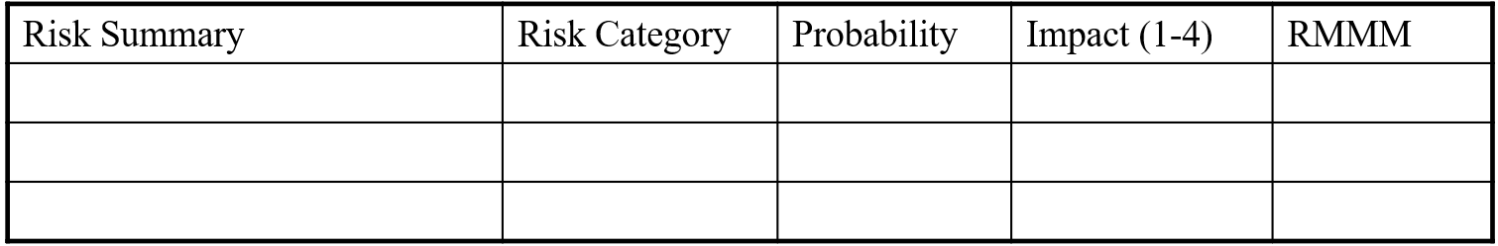
Assessing Risk Impact
Three factors affect the consequences if a risk actually happens:
- Its nature – shows the type of problems that may occur because of the risk.
- Its scope – shows how serious the risk is and how much of the project will be affected.
- Its timing – shows when the risk will affect the project and how long its effect will last.
Risk Exposure Formula
The overall Risk Exposure (RE) formula is:
$$RE=P×C$$
Where:
- P = probability that the risk will occur
- C = cost or loss to the project if the risk happens
Example
- P = 80% chance that 18 out of 60 software components will need to be redeveloped.
- C = total redevelopment cost is $25,000
So:
$$RE=0.80×25000=20000$$
Therefore, the Risk Exposure = $20,000.
Risk Mitigation, Monitoring, and Management (RMMM)
Background
An effective strategy for handling risks must consider three important issues:
- Risk mitigation (avoidance) – reducing the chance of a risk happening or avoiding it completely.
- Risk monitoring – continuously watching and tracking risks during the project.
- Risk management and contingency planning – preparing backup plans and actions in case the risk actually occurs.
Risk mitigation (avoidance) is the main strategy and is carried out through proper planning.
Background
- During risk monitoring, the project manager watches the factors that show whether a risk is becoming more likely or less likely to happen.
- Risk management and contingency planning assume that mitigation efforts have failed and that the risk has become a reality.
- RMMM activities increase the overall project cost because extra planning and management are needed.
  - Large software projects may identify around 30 to 40 risks.
- Risk is not limited only to the software development project.
- Risks can also happen after the software has been delivered and is being used by customers or users.
The RMMM Plan
The RMMM plan (Risk Mitigation, Monitoring, and Management plan) may be included in the software development plan or it may be written as a separate document.
Once the RMMM plan is prepared and the project starts, the following activities begin:
- Risk mitigation – this is an activity to avoid or reduce problems before they happen.
- Risk monitoring – this is an activity to track and observe the project to see how risks are changing.
Risk mitigation focuses on preventing risks, while risk monitoring focuses on keeping track of them during the project.
The RMMM Plan
Risk monitoring has three main objectives:
- To check whether the predicted risks actually happen or not.
- To make sure that the planned risk prevention actions are being properly followed.
- To gather information that can be used for analyzing risks in future projects.
The results of risk monitoring help the project manager understand which risks caused specific problems during the project.

Summary
Whenever a software project has a lot at stake, it is important to do risk analysis using common sense.
Risk management helps the project in several ways:
- It reduces problems and disturbances during the project.
- It improves the ability to track and control the project properly.
- It gives confidence because possible problems are planned before they happen.
Risk management may take a significant amount of time in project planning, but this effort is useful and worth it because it helps prevent bigger problems later.
Lecture 20
Risk Identification Techniques
BASIC IDEAS
A defect means a mistake, error, or problem in the software that can cause the software to work incorrectly or produce wrong results. These problems can create difficulties for both the software developers and the users.
The chance of these problems causing bad effects—such as project delays, extra costs, or software with many errors—is called risk.
BASIC IDEAS
Fault distribution is usually not equal in most software products, no matter their size, features, programming language, or other characteristics. Some parts of the software contain many faults, while other parts contain very few or no faults at all.
BASIC IDEAS
There is a strong need for risk identification techniques to study measurement data so that inspection, testing, and other quality assurance activities can focus more effectively on the software components that are likely to contain many defects.
Predictive Modeling
First, we create a predictive relationship between project measurements (metrics) and actual software defects by using past project data.
Then, this predictive relationship is used to estimate possible defects in a new project or a new software release when the project metrics become available.
In this prediction process, the main focus is on high-risk modules or components that are likely to contain many defects.
Traditional Statistical Analysis Technique
Different traditional statistical analysis techniques are used to understand the general relationship between software defects and other software measurement data.
These statistical relationships and understanding can help, to some extent, in identifying modules that may contain a large number of defects.
Correlation Analysis
Correlation is the degree of inter-relatedness among the two or more variables.
Correlation analysis is a process to find out the degree of relationship between two or more variables by applying various statistical tools and techniques.
Stages to Solve Problem
- Determine the Relationship
Find out whether a relationship exists between different variables or data. If it exists, then measure it.
- Check the Significance of Correlation
Determine whether the relationship or correlation is important and meaningful.
- Establish Cause and Effect Relationship
Identify whether one factor actually causes changes in another factor.
Types of Correlation
Positive Correlation
If one variable increase and the other variable also increase on average, it is called a positive correlation.
Example:
As the number of study hours increases, student marks also increase.
- More study hours → Higher marks
- Less study hours → Lower marks
So, both variables move in the same direction.
Negative Correlation
If one variable increase and the other variable decreases on average, it is called a negative correlation.
Example:
As the speed of a vehicle increases, the time taken to reach the destination decreases.
- Higher speed → Less time
- Lower speed → More time
So, both variables move in opposite directions.
Correlation Analysis
The value of correlation ranges from -1 to 1.
- A value close to 1 shows a strong positive correlation.
- A value close to -1 shows a strong negative correlation.
- A value close to 0 shows little or no correlation.
If the observed software defects are strongly related to a software metric, then the modules having larger values of that metric (or smaller values in case of negative correlation) can be identified as high-defect modules.
Other Techniques
- Linear regression models
- Non-linear regression models
Disadvantages
The key problem is the data treatment: data from the majority of low-defect modules dominate these statistical results, which contain little information about high-defect modules.
To overcome these limitations, alternative analysis techniques need to be used.

New Techniques for Risk Identification
- Principal Component Analysis (PCA)
- Artificial Neural Networks
- Learning Algorithms

